Project Report 

|  |  |
| --- | --- |
| **Product Name** | Applied Degree in Software Engineering (BDSE) |
| **Qualification Name** | Applied Degree in Software Engineering |
| **Product Name** | Programming Foundations |
| **Module Name (BDSE)** | **Programming Foundations** |

|  |  |  |  |  |
| --- | --- | --- | --- | --- |
| Learner name |  | | Assessor name |  |
| W.A. Chathushi Dilhari Jayarathna |  | | MRS. Ananditha, MR. Rahul & MR. Bhagya |  |
| **Date issued** | **Completion date** | | | **Submitted on** |
| 01/06/2022 | 17/06/2022 | | | 01/10/2022 |
|  |  | | |  |
| **Project title** | | Development of MCQ System | | |

|  |
| --- |
| **Learner declaration** |
| I certify that the work submitted for this assignment is my own and that research sources are fully acknowledged.      Student signature: Chathushi Date: |
|  |

Lithan | EDU Class © 2021

Table of Contents

1. Project Background 5

2. Project Objectives 5

3. Requirement Specification Document 8

4. The effectiveness of the MCQ System 9

5. Algorithm 9

5.1 Type of algorithm 10

5.1.1 Sort algorithms. 10

5.1.2 Search algorithms. 10

5.1.3 Hashing. 10

5.1.4 Dynamic Programming. 11

6. Procedural Programming 14

7. Object-Oriented 14

7.1 Encapsulation 14

7.2 Abstraction 14

7.3 Inheritance 15

7.4 Polymorphism 15

8. Event-Driven Programming 16

9. Programming Paradigms used in this project 17

10. Architecture Document 17

11. Application execution methods 18

11.1 JRE – Java Runtime Environment 18

11.2 JIT – Just in Time compiler 18

11.3 Defining the problem 18

11.4 Planning the solution 18

11.5 Coding the program 19

12. Source code of implementation for the algorithm 22

13. The way that used object-oriented features to build the application 28

14. Features that are available in IntelliJ 29

15. Steps related to debugging and how it can help develop more secure and robust applications 32

Table of Figures

Figure 1: Screenshot of IntelliJ 6

Figure 2:Screenshot of Microsoft Word Document 6

Figure 3: Screenshot of Microsoft PowerPoint Document 7

Figure 4: Screenshot of csv file 7

Figure 5: Screenshot of flow.Drawio 8

Figure 6:Screenshot of Missing info 9

Figure 7:How Hashing Algorithms Work 11

Figure 8:Example for Dynamic Programming (1) 11

Figure 9:Example for Dynamic Programming 12

Figure 10:Screenshot of MCQ system Flowchart 13

Figure 11:Screenshot of example of Abstraction 15

Figure 12:Screenshot of Example for Inheritence 15

Figure 13:Screenshot of example for polymorphsim 16

Figure 14:Screensoft for Programming Paradigms used in this project (1) 17

Figure 15:Screenshot of programming paradigms used in this project (2) 17

Figure 16:Screenshot of documenting Architecture 17

Figure 17:Application Execution Method Step 1 19

Figure 18:Application Execution Method Step 2 19

Figure 19:Application Execution Method Step 3 19

Figure 20:Application Execution Method Step 4 20

Figure 21:Application Execution Method Step 5(1) 20

Figure 22:Application Execution Method Step 5(2) 20

Figure 23:Application Execution Method Step 6(2) 21

Figure 24:Application Execution Method Step 6(1) 21

Figure 25:Application Execution Method Step 6 (3) 21

Figure 26:Application Execution Method Step 6(4) 22

Figure 27:Screenshot of source code Implementation Step 1 22

Figure 28:Screenshot of source code Implementation output Step 1 22

Figure 29:Screenshot of source code Implementation Step 2(1) 23

Figure 30:Screenshot of source code Implementation Step 2(2) 23

Figure 31:Screenshot of source code Implementation output Step 2 23

Figure 32:Screenshot of source code Implementation Step 3 24

Figure 33:Screenshot of source code Implementation Step 4 24

Figure 34:Screenshot of source code Implementation output Step 4 (1) 24

Figure 35:Screenshot of source code Implementation output Step 4(2) 25

Figure 36:Screenshot of source code Implementation Step 5 25

Figure 37:Screenshot of source code Implementation Step 6 26

Figure 38:Screenshot of source code Implementation output Step 6 26

Figure 39:Screenshot of source code Implementation Step 7 26

Figure 40:Screenshot of source code Implementation output Step 7(1) 27

Figure 41:Screenshot of source code Implementation output Step 7(2) 27

Figure 42:Screenshot of source code Implementation Step 7 28

Figure 43:Screenshot of source code Implementation Step 8 28

Figure 44:Screenshot of source code Implementation output Step 8 28

Figure 45:ScreenShot of the way that use OOP (1) 28

Figure 46::Screenshot of the way that use OOP (2) 29

Figure 47:Screenshot of IntelliJ shortcuts (ctrl + space) 29

Figure 48:Screenshot of IntelliJ infection & quick fix 30

Figure 49:Screenshot of IntelliJ Automatic JDK Download 30

Figure 50:Screenshot of IntelliJ Automatic JDK download 30

Figure 51:Screenshot of Breakpoints 33

Figure 52:Screenshot of debug the main class 34

Figure 53:Screenshot of IntelliJ program analyze 34

Figure 54:Screenshot of running program 35

Figure 55:Screenshot of Coding Standards (Naming Convention) 1 35

Figure 56:Screenshot of Coding Standards (Naming Convention) 2 36

Figure 57:Screenshot of Coding Standards (Comments) 36

Figure 58:Screenshot of Coding Standards (Maintain Indentation) 36

Figure 59:Screenshot of coding standards (Using camel case) 37

1. **Project Background**

* **Project Definition**

This project is about the MCQ System. This MCQ system must create using Java because Java is an excellent choice for developing systems. The education market wants to expand their market into the Information Technology subject areas for the part of their development. Therefore, their internship training is required to develop and develop software to assess subject knowledge. So, the company provided the MCQ system.

Thus, the system must handle several MCQ kits, such as Java Basics, Control Structure, HTML, and CSS, and after selecting the kit, the system should display questions from the selected list. Then allow users to answer and calculate points based on their answers. For example, if the user answers 5 out of 10 questions correctly, the score should be 50%

1. **Project Objectives**

* **Proposed Solutions**
* Add Input user ID and password
* Develop a system like when finished answering one set of MCQs, the other MCQ sets will appear
* **Development Tools**
* IntelliJ – To coding

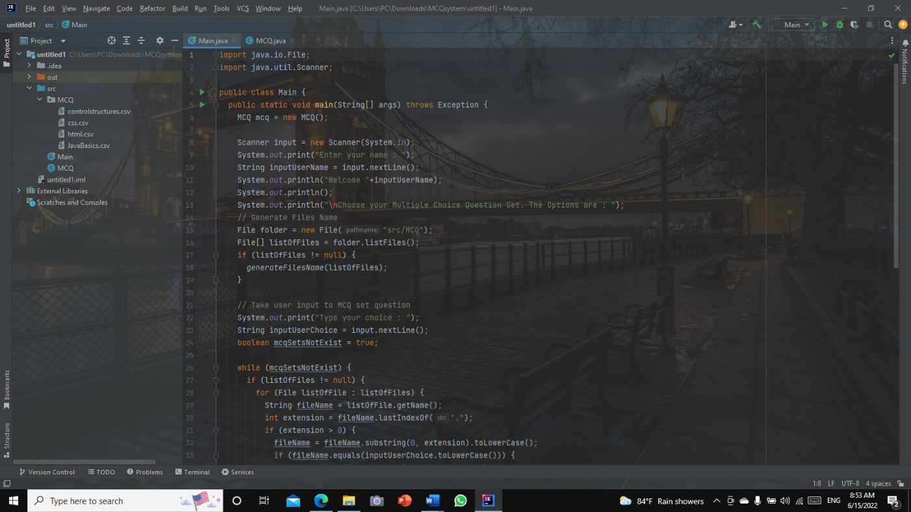

Figure 1: Screenshot of IntelliJ

* 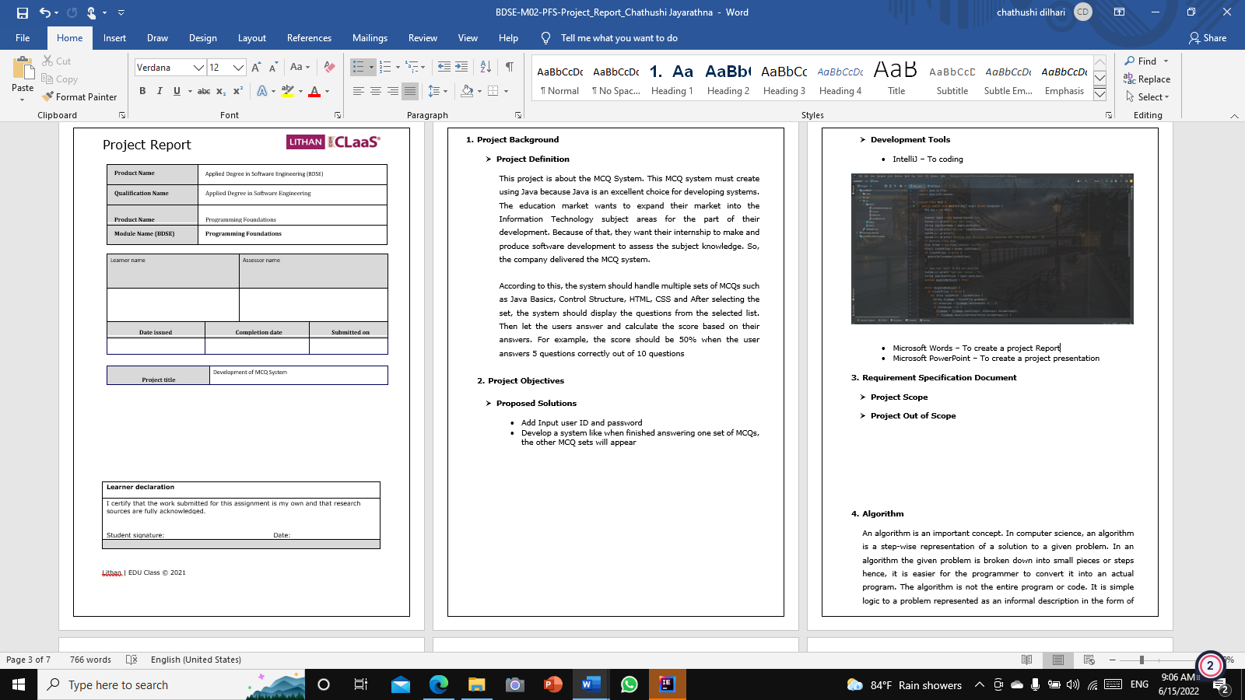Microsoft Words – To create a project Report

Figure 2:Screenshot of Microsoft Word Document

* Microsoft PowerPoint – To create a project presentation

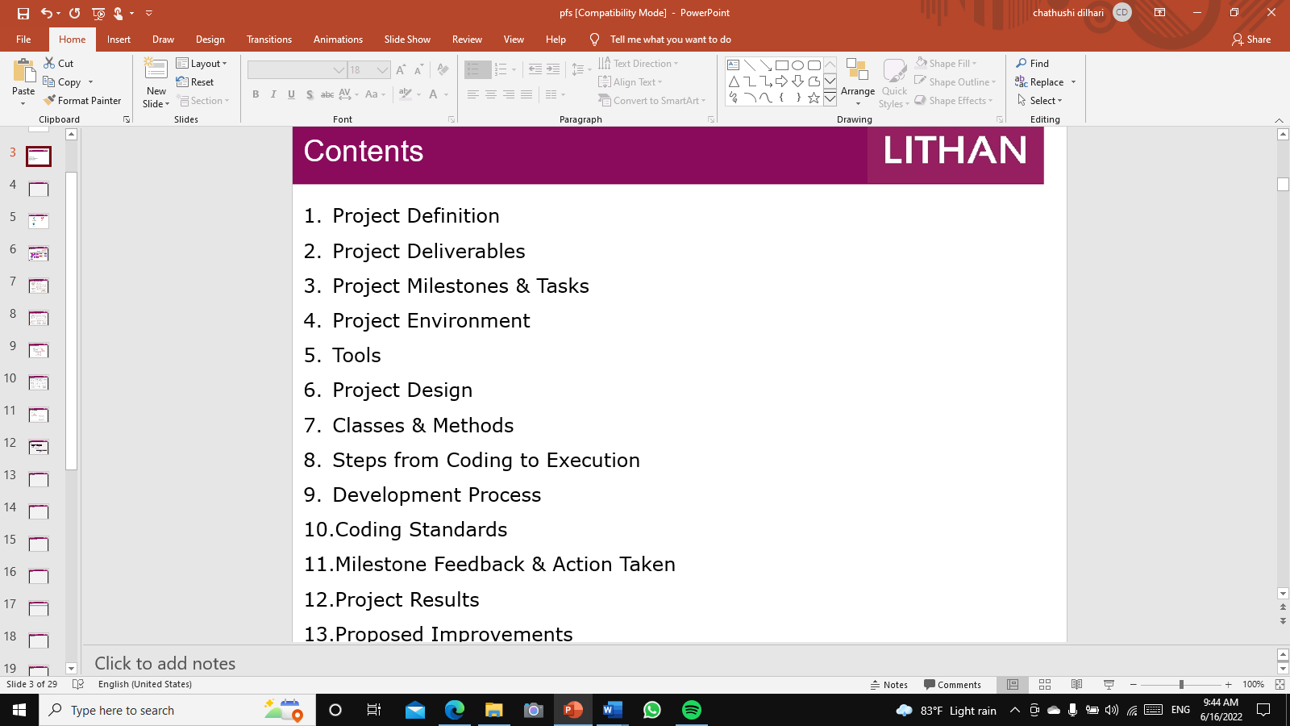

Figure 3: Screenshot of Microsoft PowerPoint Document

* Microsoft Excel – To create MCQ CSV files

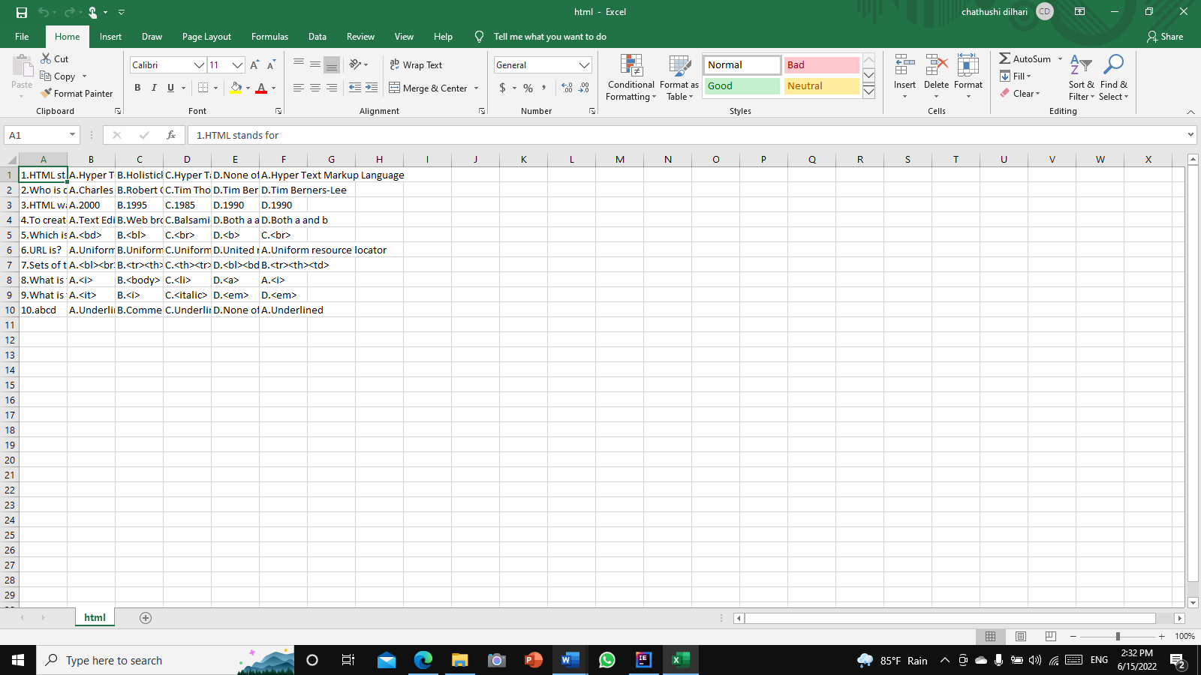

Figure 4: Screenshot of csv file

* Flow. Drawio – To create a flowchart

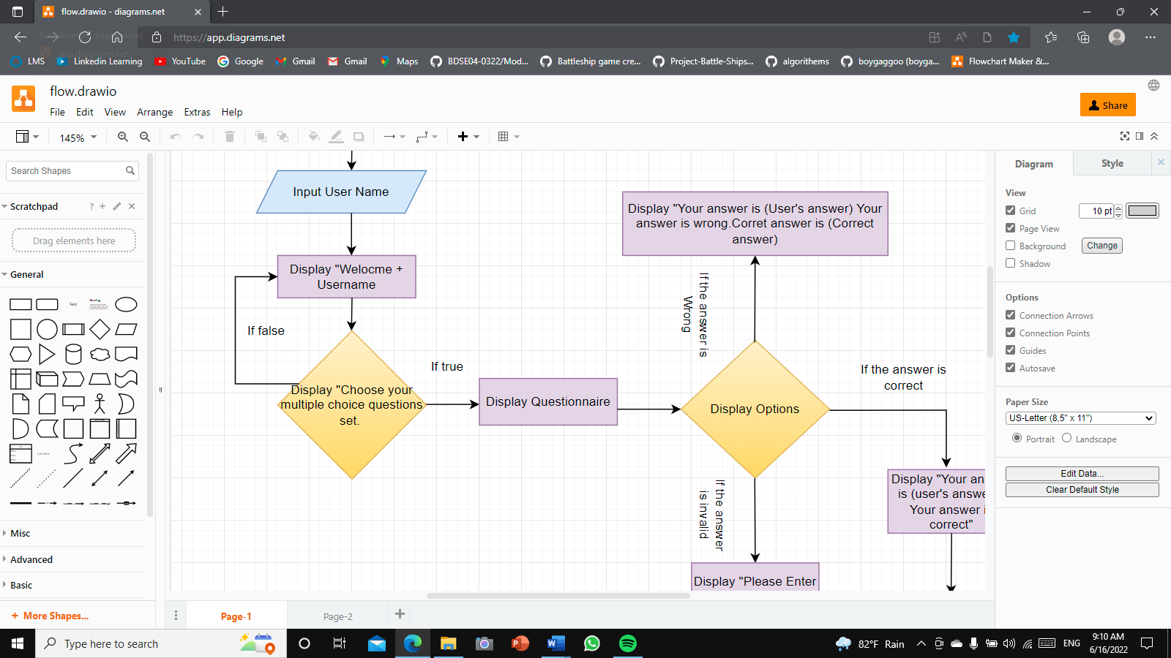

Figure 5: Screenshot of flow.Drawio

1. **Requirement Specification Document**

* **Project Scope**

MCQ system – This is the MCQ system, anyone can enter their name and provide answers. There are four types of MCQ sets from four categories such as HTML, CSS, Control Structure, and Java Basics.

* **Project Out of Scope**
* Adding Progress
* Chance for Repeat MCQs

1. **The effectiveness of the MCQ System**

The system has a user-friendly interface, this system is quite simple students can select their very own question units, including four multiple choice questions (MCQs). Student can choose one set of questions from them. Then answer all the MCQs which will conclude test. At the end, they will get the number of questions they answered right and wrong and the final mark as a percentage.

**Missing Info**

* Using a number for more convenience while selecting MCQ sets

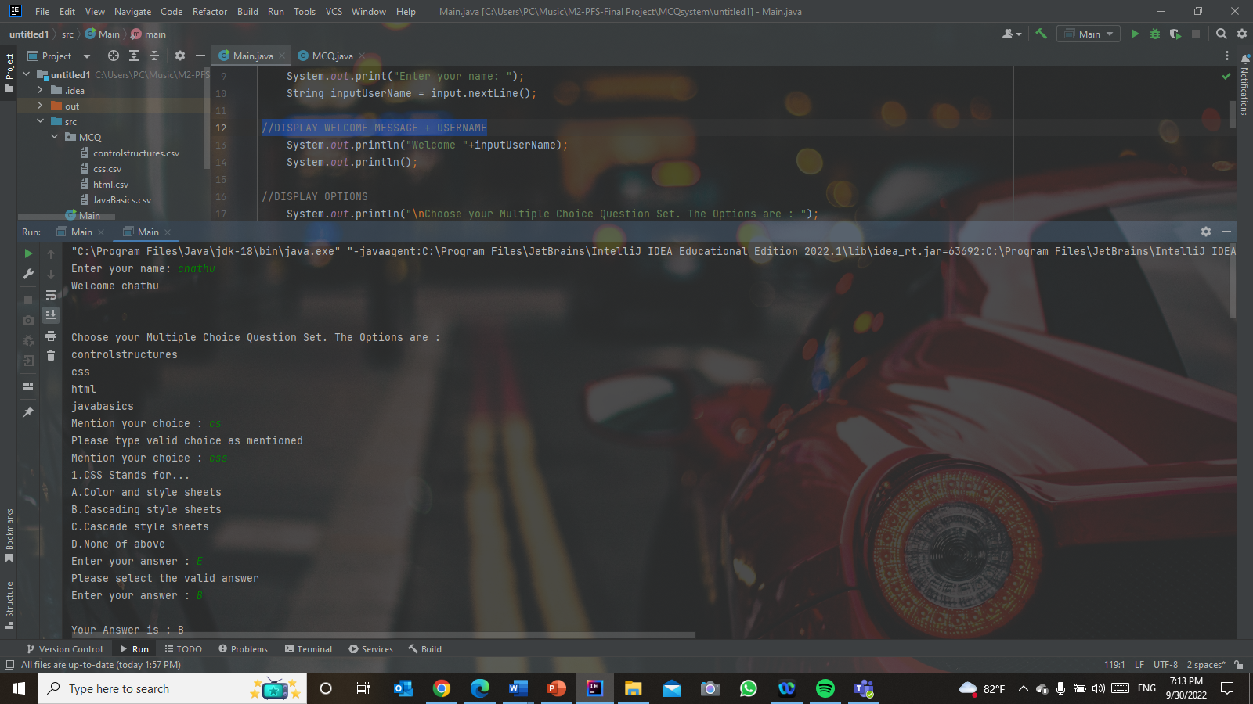

Figure 6:Screenshot of Missing info

1. **Algorithm**

An algorithm is a system used for solving a problem or performing a computation. Algorithms act as a particular listing of commands that conduct distinctive actions step by step in both hardware- or software-primarily based routines.

Algorithms are extensively used throughout all areas of IT. In mathematics and computer science, an algorithm commonly refers to a small process that solves a recurrent problem. Algorithms are also used as specifications for performing data processing and play a prime function in computerized systems.

An algorithm can be used for sorting units of numbers or for extra complicated tasks, like recommending user content material on social media. Algorithms commonly begin with preliminary input and commands that describe a specific computation. while the computation is achieved, the procedure produces an output.

An algorithm is not a complete program or code. It is a simple argument for a problem that is represented as an informal description in the form of a flow chart. Programming algorithms range in size from simple to complex, depending on the type of task required to perform them.

* 1. **Type of algorithm**

A programming algorithm is a procedure or formula used for solving a trouble. it is based on conducting a sequence of distinctive actions in which those actions describe how to do something, and your pc will do it exactly that way each time. An algorithm works by using following a technique, made from inputs. once it has followed all of the inputs, it will see an end result, also called output.

* + 1. **Sort algorithms.**

A Sorting algorithm is used to arrange a given array or listing of elements in step with an evaluation operator at the factors. The contrast operator is used to decide the brand-new order of factors in the respective data structure.

* + 1. **Search algorithms.**

An element can be tested for or retrieved from any data structure that stores it using search algorithms. These algorithms are typically divided into two groups based on the type of search operation

* Sequential Search
* Interval Search
  + 1. **Hashing.**

Many different hashing algorithms exist, and they all work somewhat better. Yet, in every one, individuals type in information, and the program modifies it to an alternate structure.

Some hashing algorithms are;

* Mathematical
* Uniform
* Consistent
* 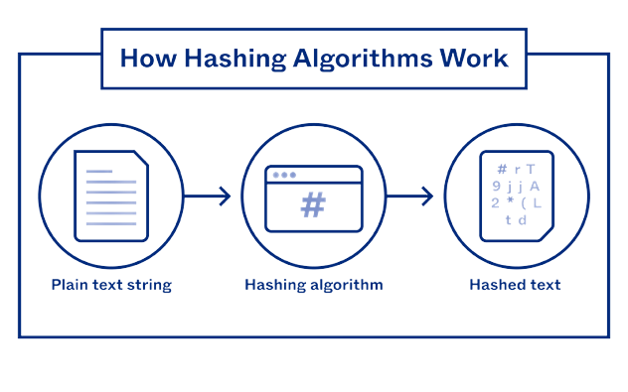One way

Figure 7:How Hashing Algorithms Work

* + 1. **Dynamic Programming.**

Dynamic programming is an algorithmic strategy that is firmly connected with the separation and vanquish approach we found in the past section. Notwithstanding, while the separation and overcome approach is basically recursive, thus "top down," unique programming works "base up". A unique programming calculation makes a variety of related yet less difficult subproblems, and afterward, it registers the answer for the huge confounded issue by utilizing the answers for the simpler subproblems which are put away in the exhibit. We for the most part need to boost benefits or limit costs.

Example;

* 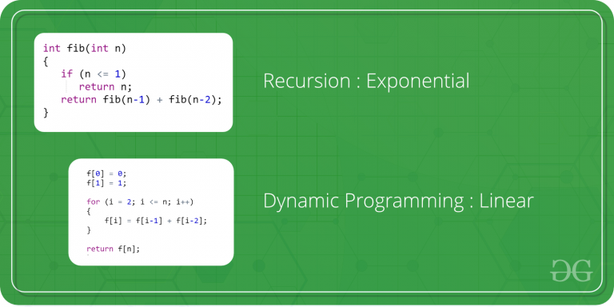Recursion: Exponential

Figure 8:Example for Dynamic Programming (1)

* Dynamic Programming: Linear

Figure 9:Example for Dynamic Programming

* **Algorithm design for project scenario:**

Step 1 - Start

Step 2 - Take username input "Enter your name"

Step 3 - Display a welcome message with the user name

Step 4 - Output the List of questionnaires

1. Control Structure
2. CSS
3. HTML
4. Java Basics

Step 5 - Select an MCQ set

Step 6 - Output the selected questionnaire (CSS Questionnaire)

Step 7 – If the condition is true start displaying the questionnaire that the user chooses

Step 8 – Display “Enter Your Answer”

Step 9 – Input the answer

Step 10 – Check whether the answer is correct or not or invalid

Step 11- If the answer is correct, Display “Your answer is ___ (User Answer), Your Answer is correct”

Step 12 – If the answer is wrong, Display “Your answer is___ (User Answer)”

Step 13 – Display “Your answer is wrong, Correct answer is ___ (Correct Answer)”

Step 14 – If the user enters an invalid answer, Display “Please Enter the valid answer”

Step 15 – Successfully answered 10 questionnaires, Display “username + “You answered ___ (No of correct questions) questions right, ___ (No of incorrect questions) questions wrong for a total of 10 questions. You scored ___% (Percentage of points scored by the user)

Step 16 – End

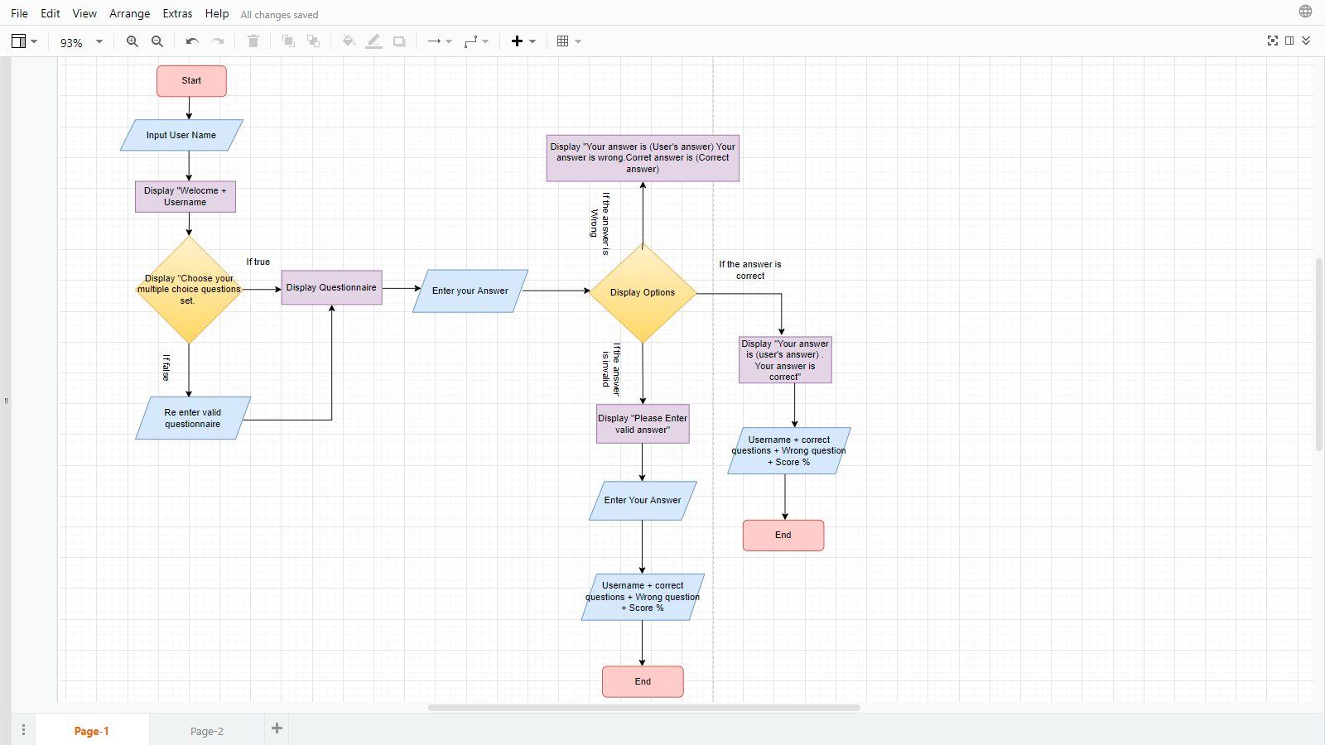

Figure 10:Screenshot of MCQ system Flowchart

1. **Procedural Programming**

Procedure Programming is a programming technology derived from structured programming that is based on the concept of calling action procedures. This is the first programming model that a new developer will learn. Procedures, often referred to as routines, subtitles, or functions, are essentially a series of instructions to follow. Procedure code is a direct instruction to a device on how to complete a task from logical steps.

The programming languages ​​used to execute a programming program are BASIC, C, Pascal, and FORTRAN.

1. **Object-Oriented**

Object-oriented programming is a basic programming model built around the concept of objects that can contain data in the form of fields, often referred to as properties; And code, in the form of a syllabus, often referred to as a syllabus, is the most popular programming model and teaches the standard syllabus for coding most of a programmer's academic career. There are several key principles of OOP,

* 1. **Encapsulation**

(Binding code and data together in a single unit)

Encapsulation, often known as OOP Encapsulation, is the process of grouping together methods that operate on data and data itself in object-oriented computer programming (OOP) languages. Encapsulation is widely used in the form of classes in several programming languages. A class is a structure for program code that enables programmers to design objects with variables (data) and behaviors (functions or methods). In computer science, encapsulation can be seen in the form of classes, which are collections of data and methods.

* 1. **Abstraction**

(Hiding internal details and showing just the functionality to the user)

Reflection is the most common way of removing or eliminating qualities from something to lessen it to a bunch of fundamental qualities. In object-oriented programming, reflection is one of three focal standards Through the course of abstraction, a developer conceals everything except the significant information about an item to lessen intricacy and increment proficiency. Similarly, that reflection at times works in craftsmanship, the item that remains is a portrayal of the first, with undesirable detail discarded. The subsequent item itself can be alluded to as an abstraction, meaning a named element comprised of chosen credits and conduct well defined for a specific use of the starting substance. Abstraction is connected with both encapsulation and data hiding.

Using this object, a user can Call the Method from the object

By using the default Constructor can Create an object of the MCQ to the main class.

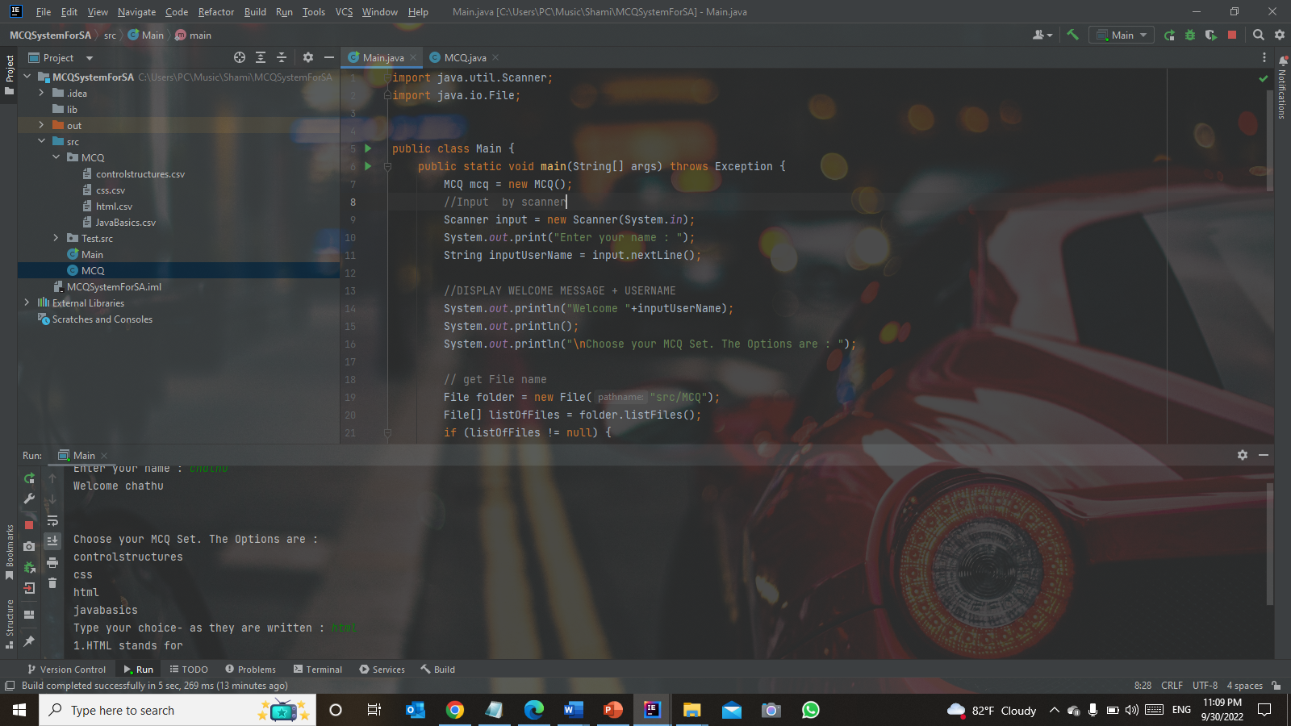

Figure 11:Screenshot of example of Abstraction

* 1. **Inheritance**

(The child class inherits properties from the parent class)

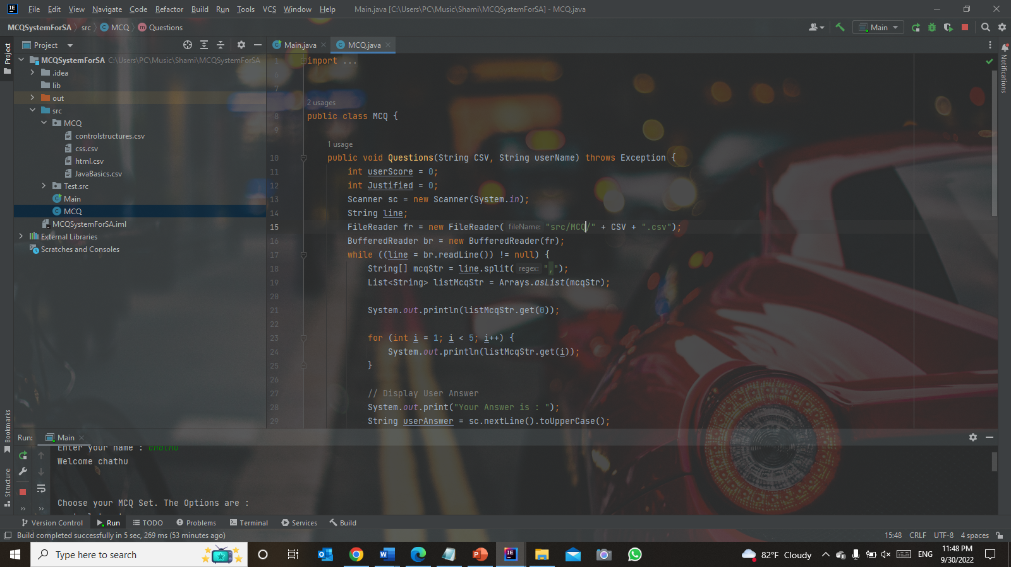One of the most crucial elements of Object-Oriented Programming is inheritance (OOP). The fact that inheritance allows for code reuse is the key to understanding it. We can just inherit the properties of one class into the other rather of repeatedly writing the same code.

Figure 12:Screenshot of Example for Inheritence

* 1. **Polymorphism**

(One task is performed differently)

One of the fundamental ideas of object-oriented programming (OOP), polymorphism addresses circumstances where something happens in a variety of ways. It refers to the idea in computer science that you can access objects of many types through the same interface. Each type may offer a unique, autonomous implementation of this interface.

You can see that the question class is already inheriting all methods, even though after the if/else statement's justification, "System.out.println()" can add all strings to a line by using the "+" symbol, which is also an inheriting property. This is referred to be one type of overriding.

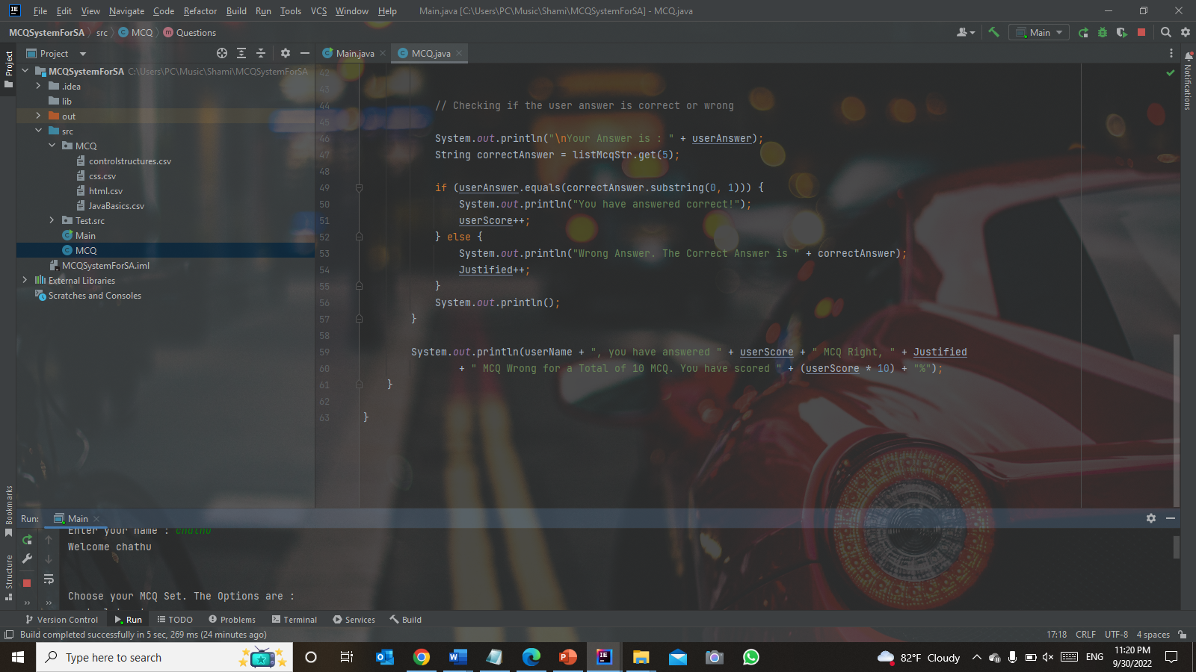

Figure 13:Screenshot of example for polymorphsim

Programming languages used to implement Object-Oriented Programming are Java, JavaScript, C#, C++, Python, PHP, etc.

1. **Event-Driven Programming**

In computer science, Event-Driven Paradigms are programming models that determine the flow of a program, such as user actions, sensor outputs, or other programs or messages from a thread. This program can be written in any programming language. Almost all object-oriented and visual languages ​​support event-based programs. Such as Visual Basic, Visual C ++, and Java.

1. **Programming Paradigms used in this project**

The project’s use of object-oriented features includes creating an object of the MCQ for the main class using the default constructor. You can call the method from this object by using it.

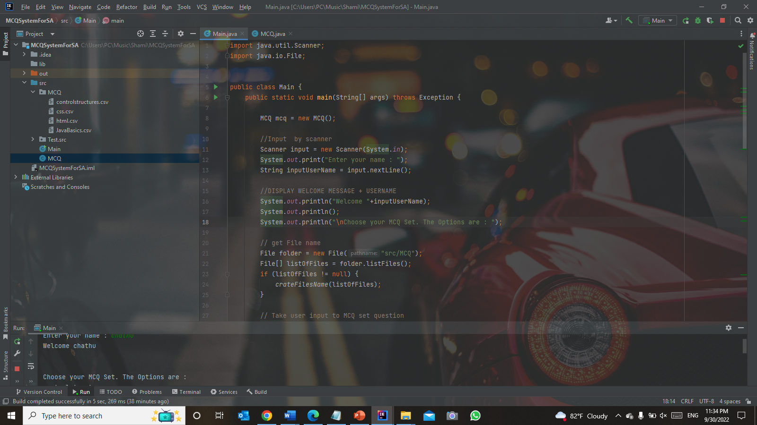

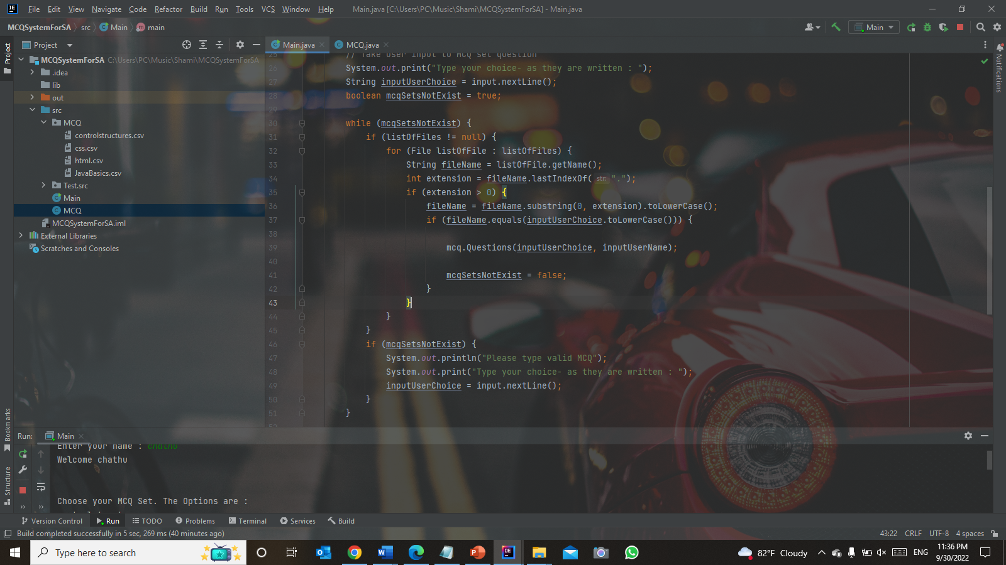Figure 14:Screensoft for Programming Paradigms used in this project (1)

Figure 15:Screenshot of programming paradigms used in this project (2)

1. 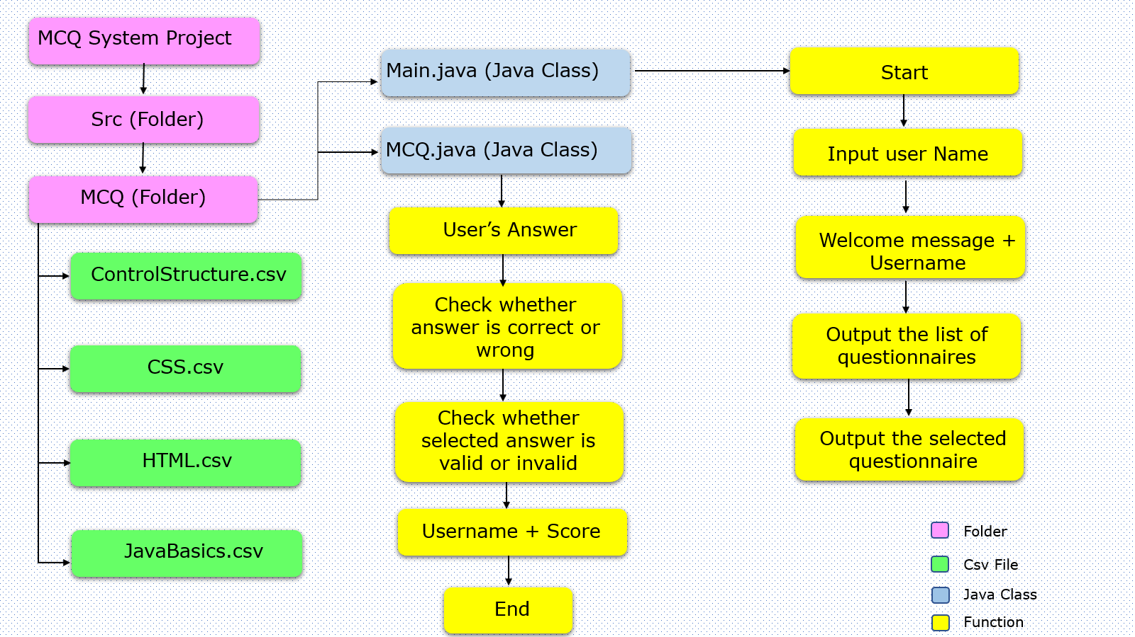**Architecture Document**

Figure 16:Screenshot of documenting Architecture

* MCQ System Project Folder– Contain all MCQ system files
* src Folder– Contain all Source Codes
* MCQ Folder – Contains all MCQ CSV files

CSV Files

* controlstrucure.csv – contains 10 MCQs of control structure
* css.csv – Contain 10 MCQs of CSS
* html.csv – Contain 10 MCQs of HTML
* javabasics.csv – Contain 10 MCQs of Java Basics

Java clasees

MCQ.java

* MCQ.java – Main class of the project
* Main.java – MCQ system coding

1. **Application execution methods**
   1. **JRE – Java Runtime Environment**

Java Runtime Environment is a layer of software that runs on a computer’s operating system software and provides class libraries and other resources needed to execute a specific java program.

It runs on any device supporting the java platform a& It is the topmost layer of the machine’s OS

* 1. **JIT – Just in Time compiler**

JIT in Java is a mandatory part of JVM (Java Virtual Machine). It speeds up activation performance many times more than the previous level

* 1. **Defining the problem**

Before writing the code it’s better to know what is the problem first. In this project of developing an MCQ System, there are some problem

That can be defined like;

* What should we use to take user input from the console
* How to read and display the CSV file from the java program
* How to validate user input
* How to make the score when the user answering the MCQ
  1. **Planning the solution**

After we defining the problem, the next step is planning the solution. These are the solution for given problem above;

* Using scanner to take user input from the console
* Reading the CSV file using FileReader
* Using if-else statement and loop to validate the user input
* Using variable score and adding the score when the user answers correctly
  1. **Coding the program**

After defining and planning the problem is done, we can now start to code the program according to the plan.

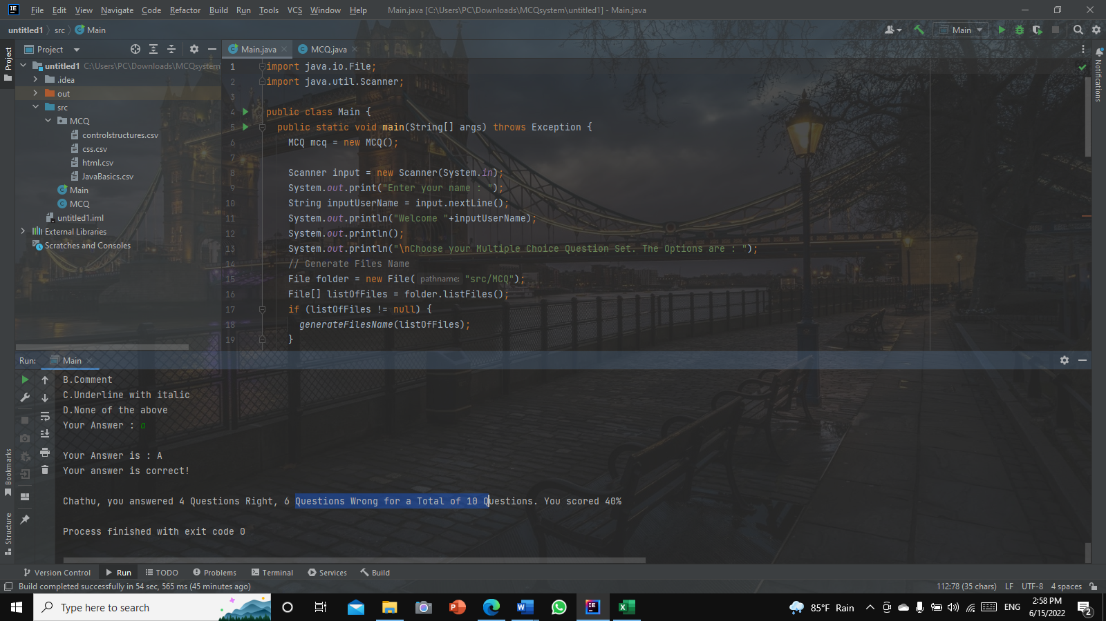**Step 1** - Taking user input using Scanner

Figure 17:Application Execution Method Step 1

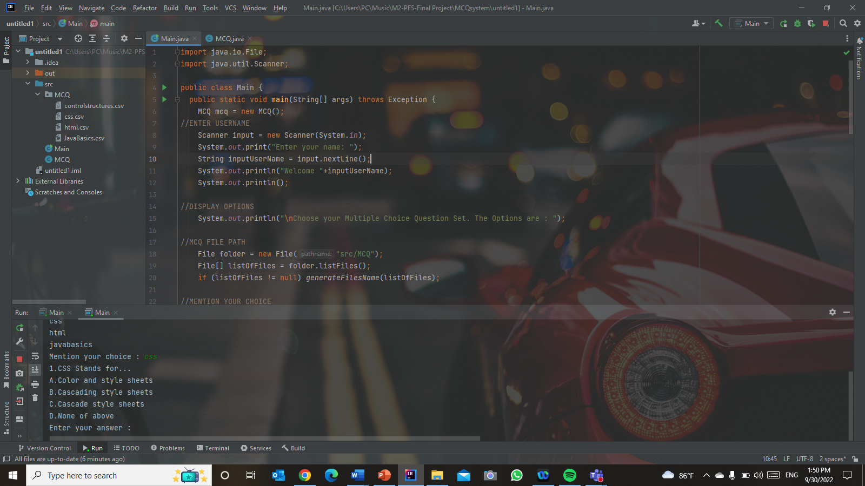**Step 2 - Print the welcome message + username**

Figure 18:Application Execution Method Step 2

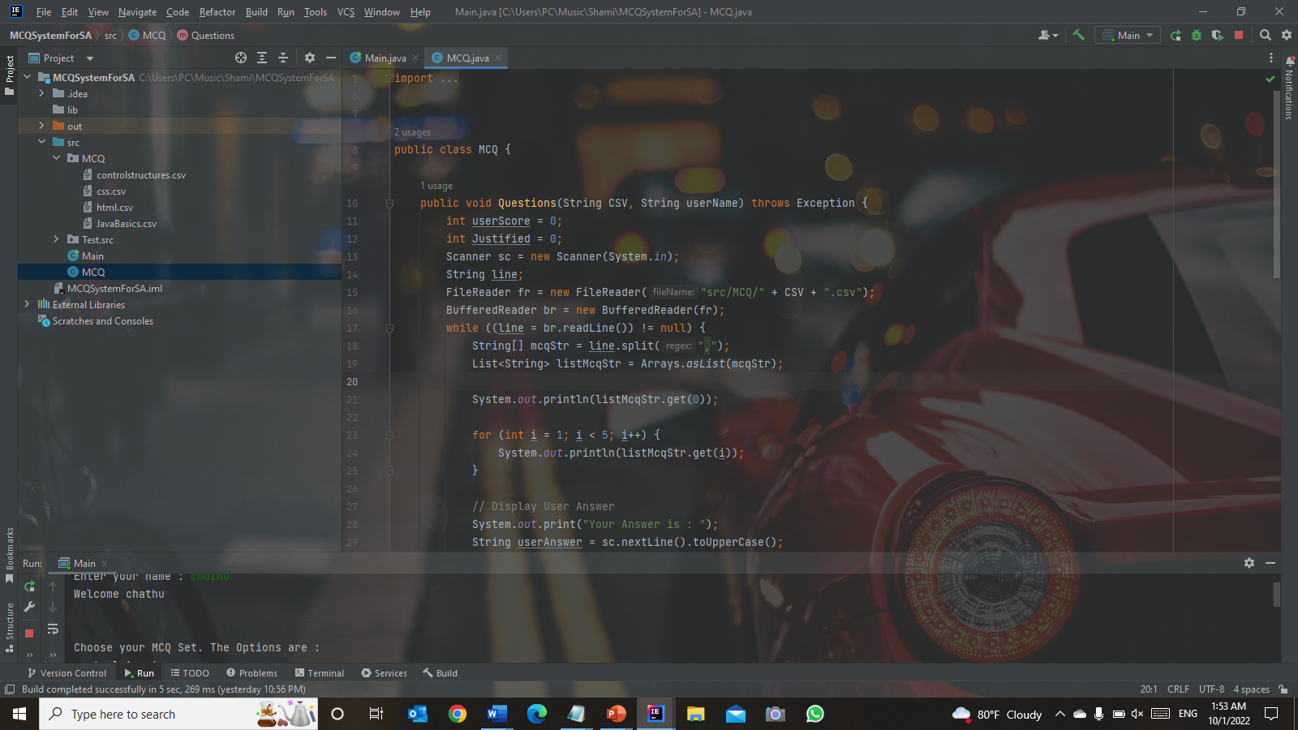**Step 3 -** Reading the CSV file using FileReader

Figure 19:Application Execution Method Step 3

**Step 4 -** Validate user input so they type correct input

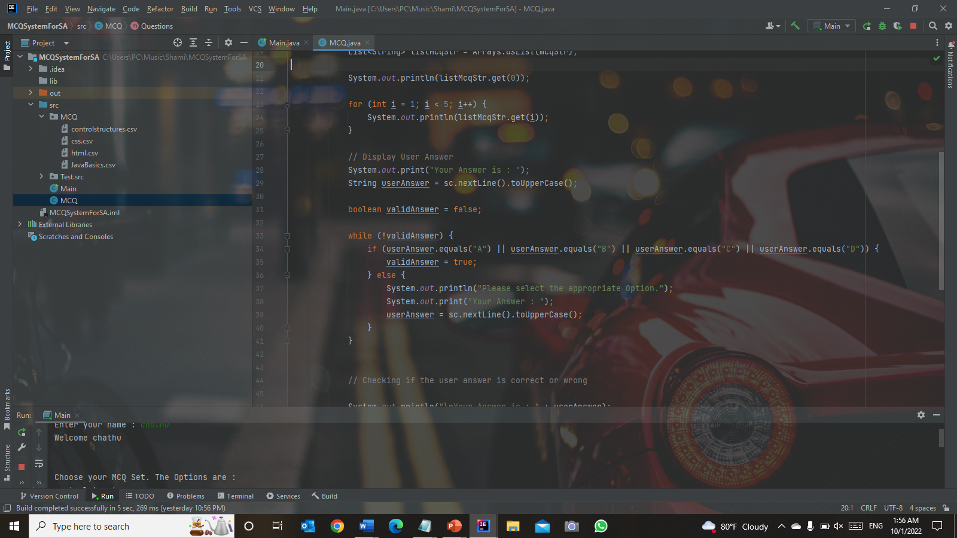

Figure 20:Application Execution Method Step 4

**Step 5 -** Checking user answer are correct or wrong and calculating user Score

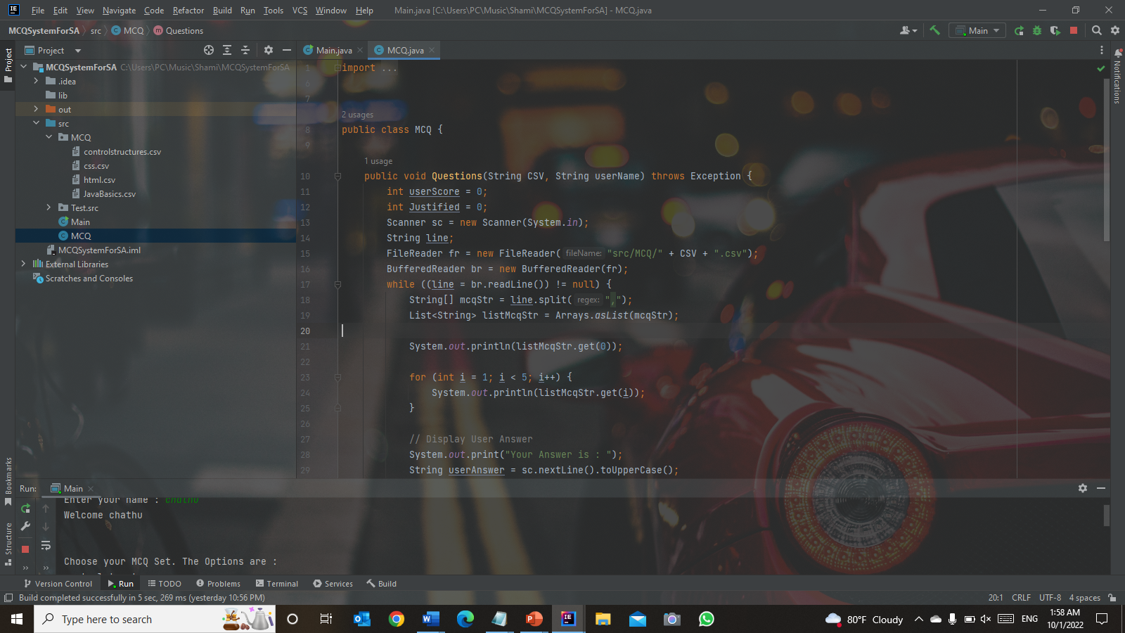

Figure 21:Application Execution Method Step 5(1)

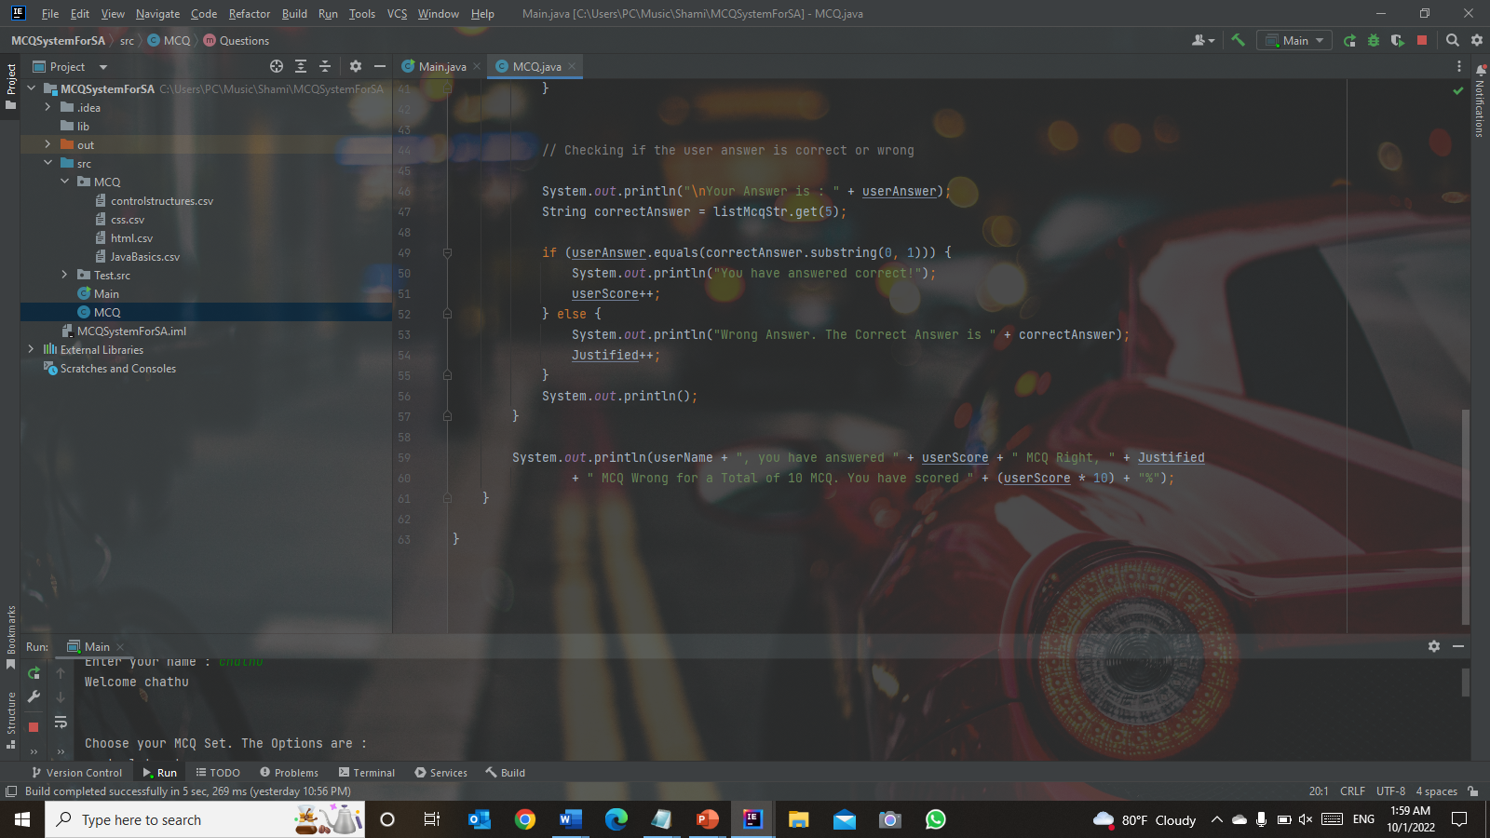

Figure 22:Application Execution Method Step 5(2)

**Step 6 - Executing the program**

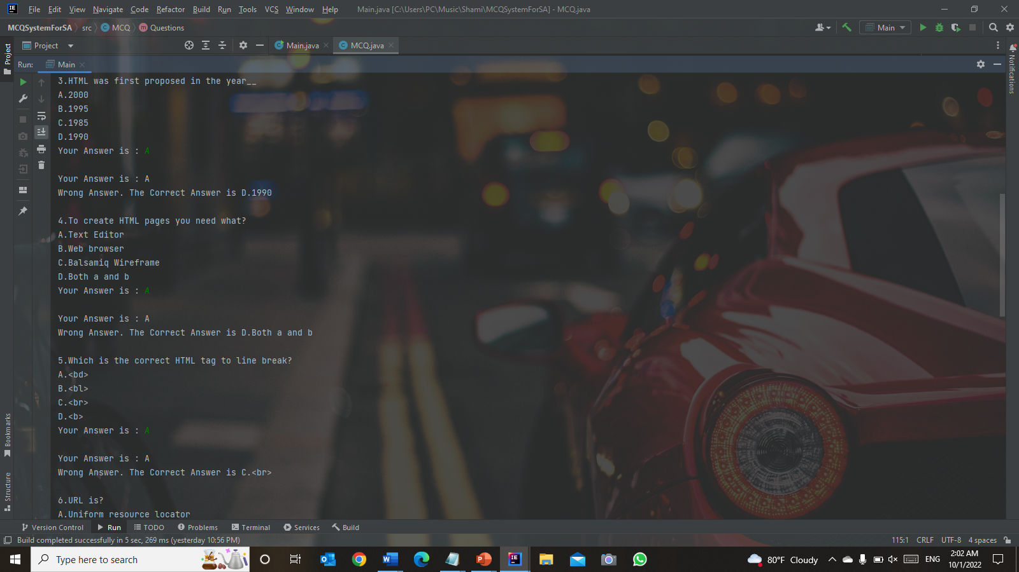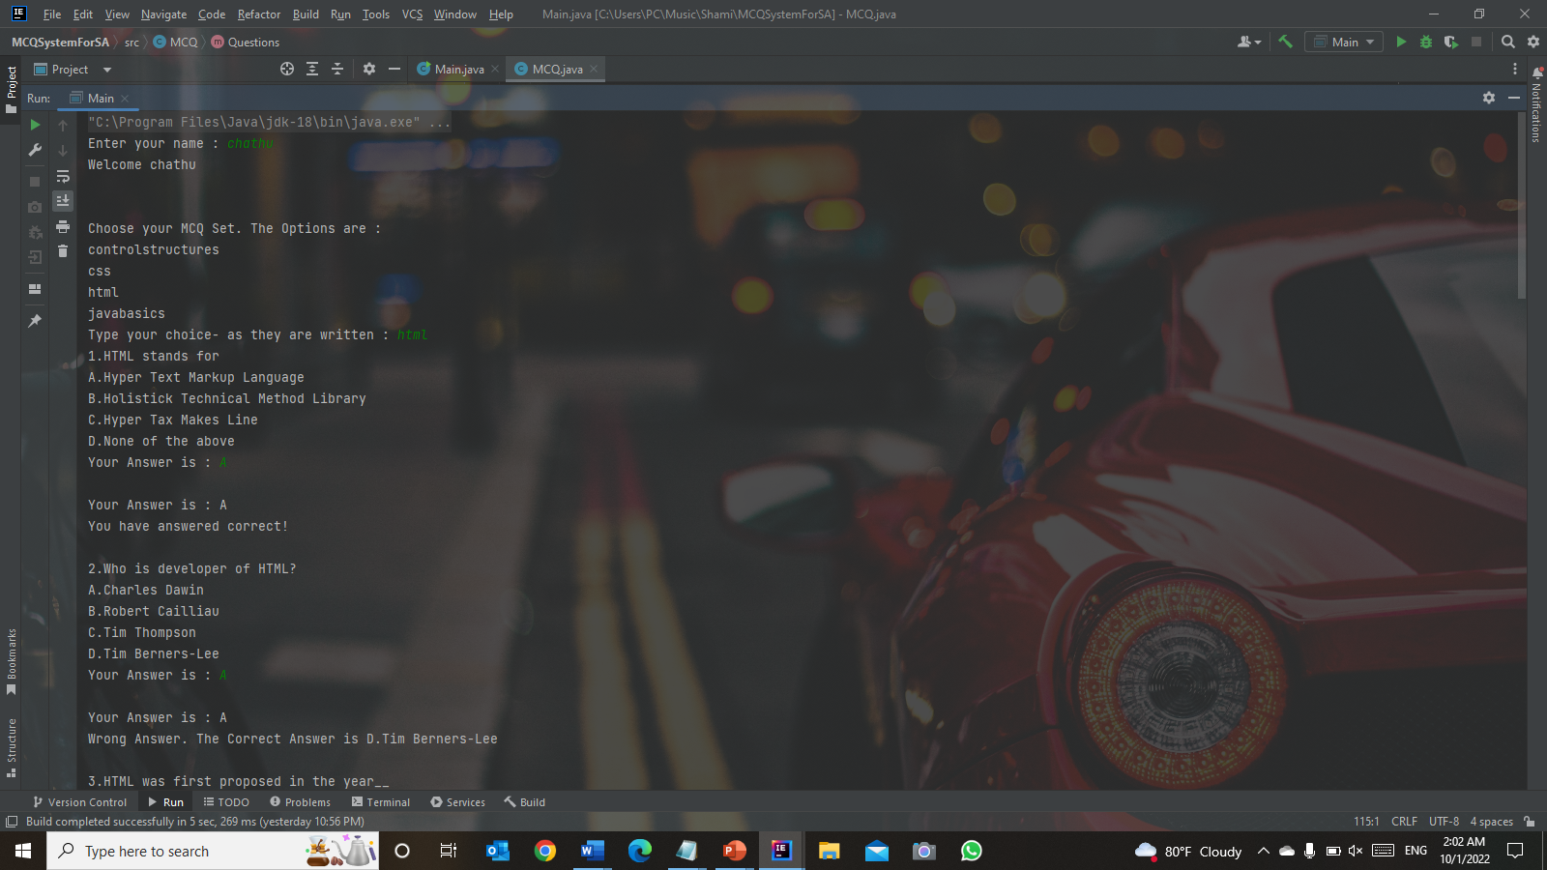

Figure 23:Application Execution Method Step 6(2)

Figure 24:Application Execution Method Step 6(1)

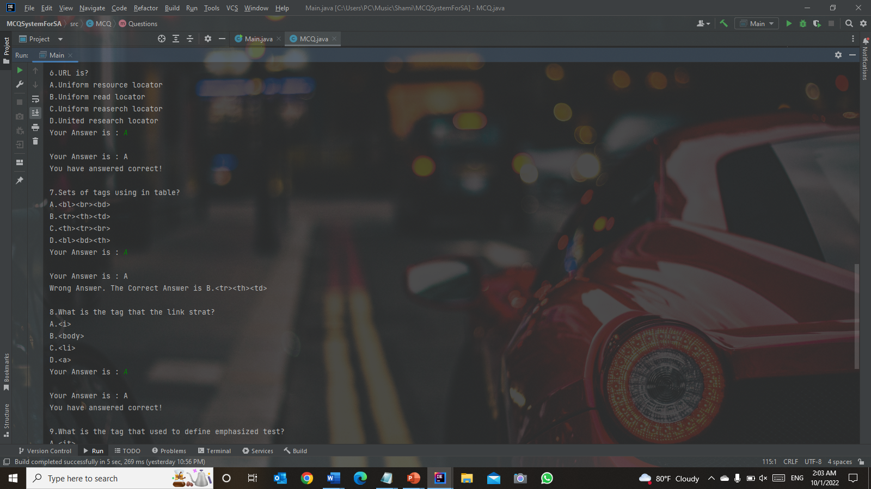

Figure 25:Application Execution Method Step 6 (3)

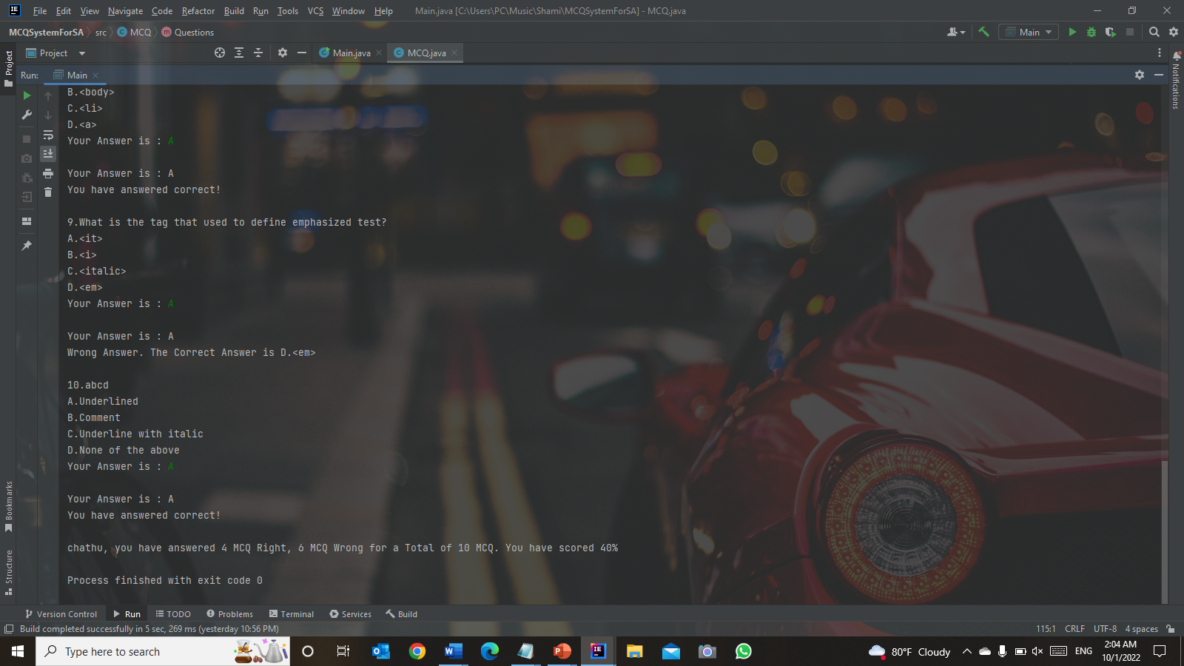

Figure 26:Application Execution Method Step 6(4)

1. **Source code of implementation for the algorithm**

**Step 1 -** Taking user input using “Scanner”, user will be required to be inputting their name in the first time the program started.



Figure 27:Screenshot of source code Implementation Step 1

**Output –** Print “Enter your name” and welcome message + username

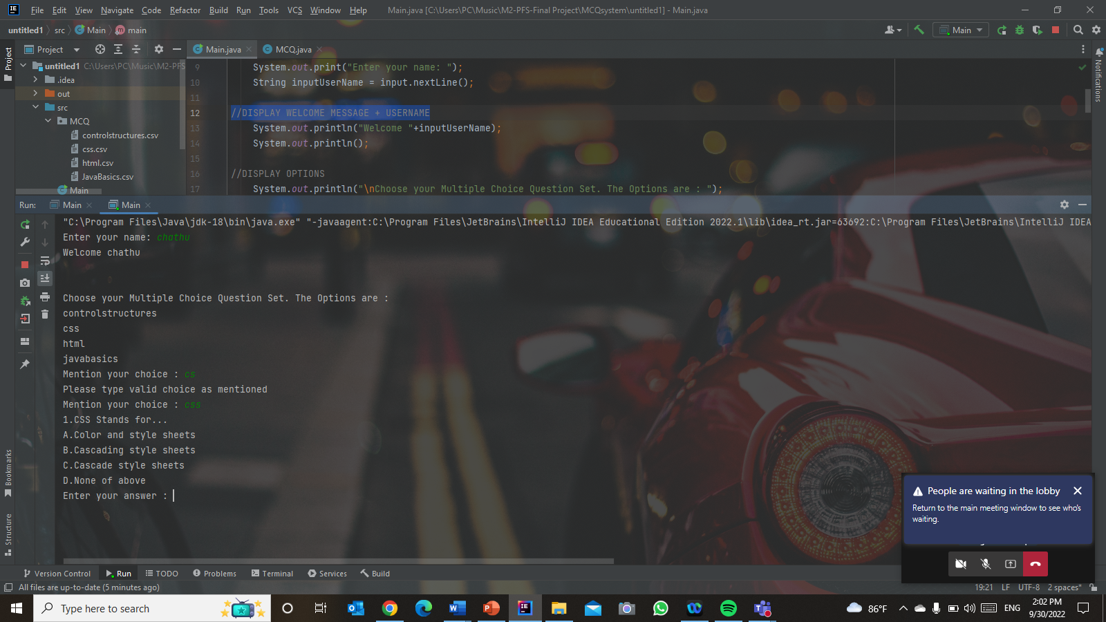

Figure 28:Screenshot of source code Implementation output Step 1

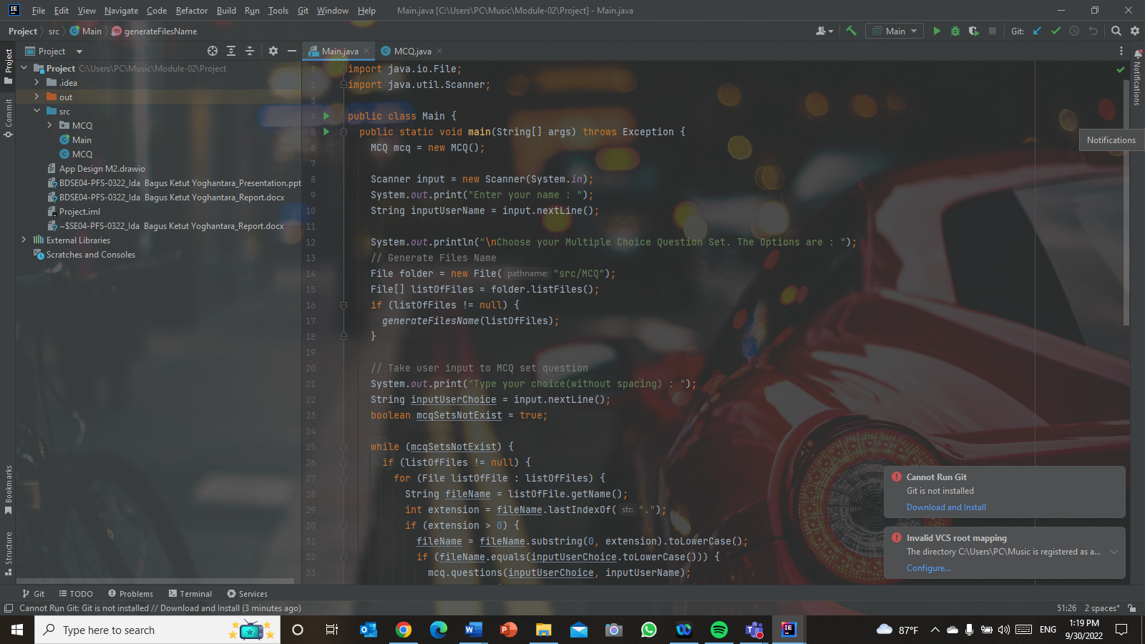**Step 2 –** Using “File” Class imported from java.io.File, read all the files in the MCQ folder and get all the list of files, after that here we are using method called “generateFilesName” that given parameter of listOfFiles array.

Figure 29:Screenshot of source code Implementation Step 2(1)

In the method “generateFilesName”, loop through all the files and print all the file name into the console without the extension.

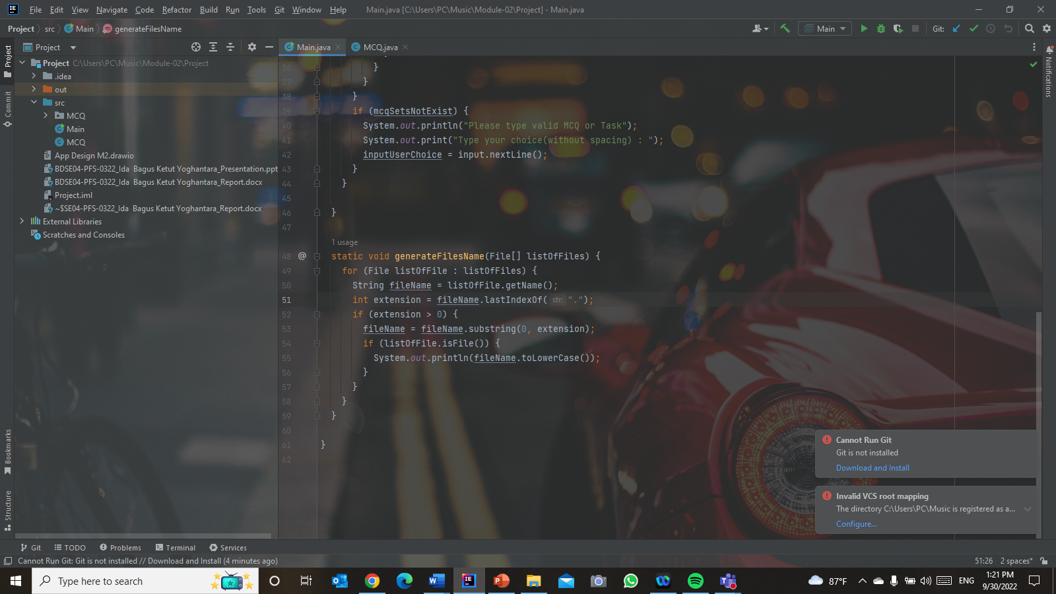

Figure 30:Screenshot of source code Implementation Step 2(2)

**Output** – Showing MCQs sets list



Figure 31:Screenshot of source code Implementation output Step 2

**Step 3 –** Taking the user input for them to selecting the MCQ

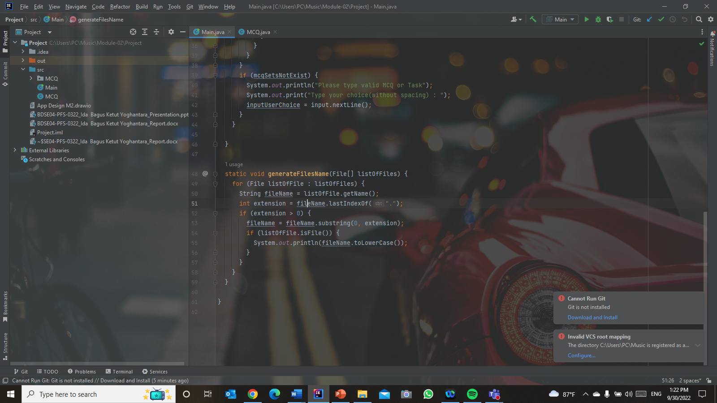

Figure 32:Screenshot of source code Implementation Step 3

**Step 4** - Checking user input if they inputting invalid MCQ or Task

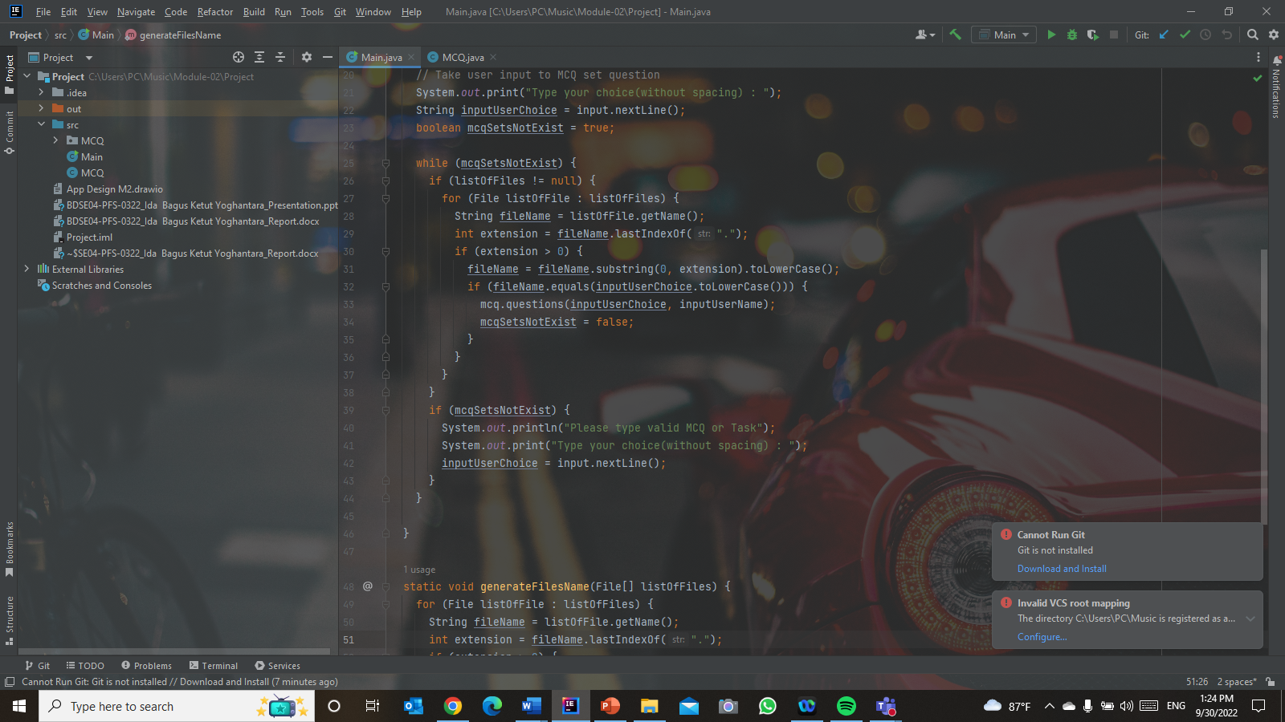

Figure 33:Screenshot of source code Implementation Step 4

**Output** - If user input invalid task name



Figure 34:Screenshot of source code Implementation output Step 4 (1)

**Output** – If user input valid task name



Figure 35:Screenshot of source code Implementation output Step 4(2)

**Step 5** - Displaying the question and the multiple choice according to user input after they select the MCQ or Task.

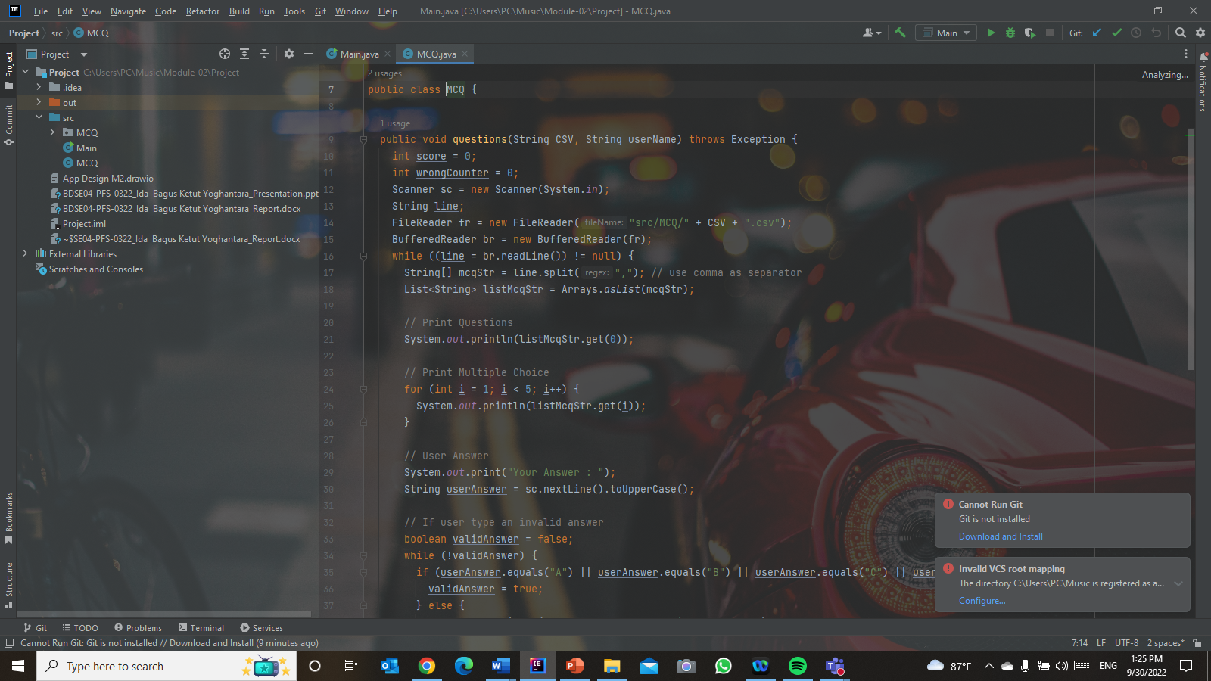

Figure 36:Screenshot of source code Implementation Step 5

**Step 6** - Taking user answer

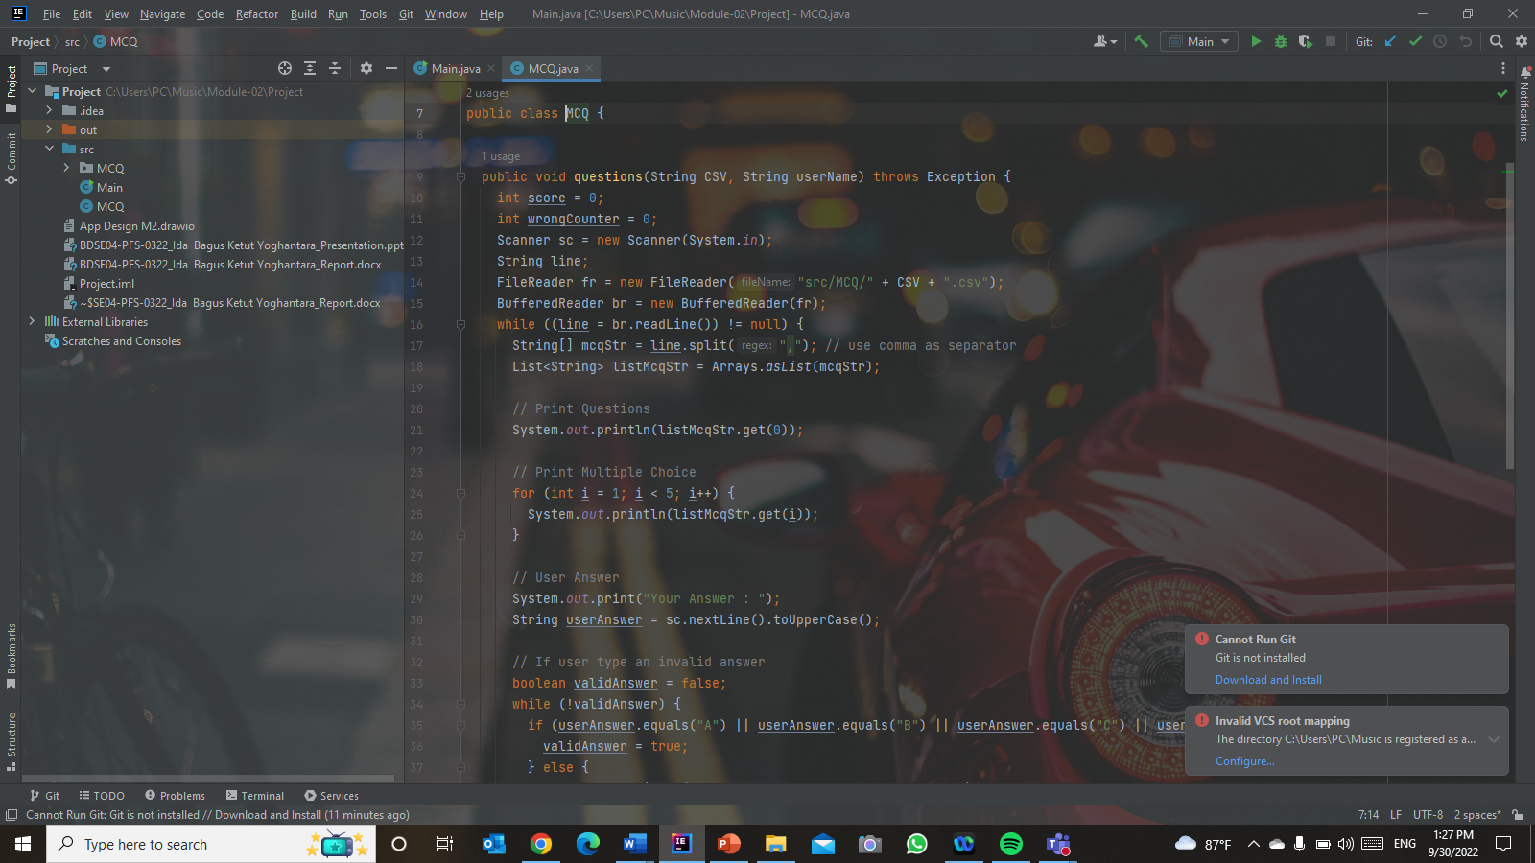

Figure 37:Screenshot of source code Implementation Step 6

**Output** – Input field to enter answer

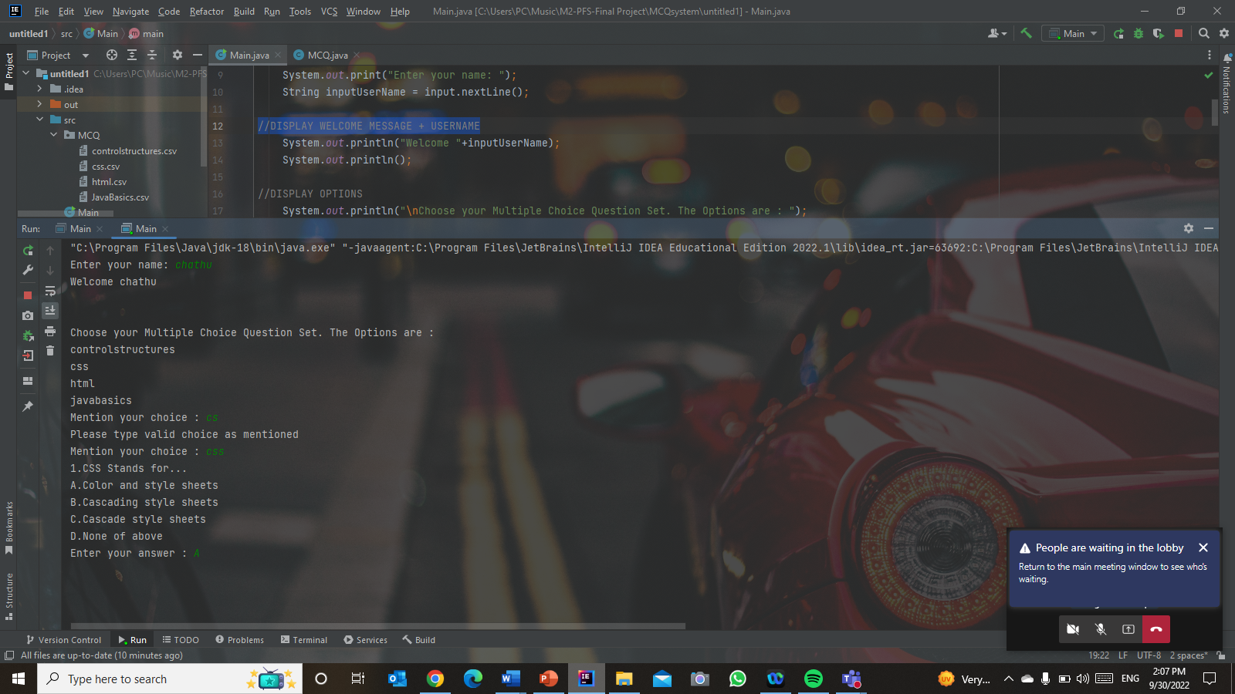

Figure 38:Screenshot of source code Implementation output Step 6

**Step 7** - Checking if the user inputting valid answer or not

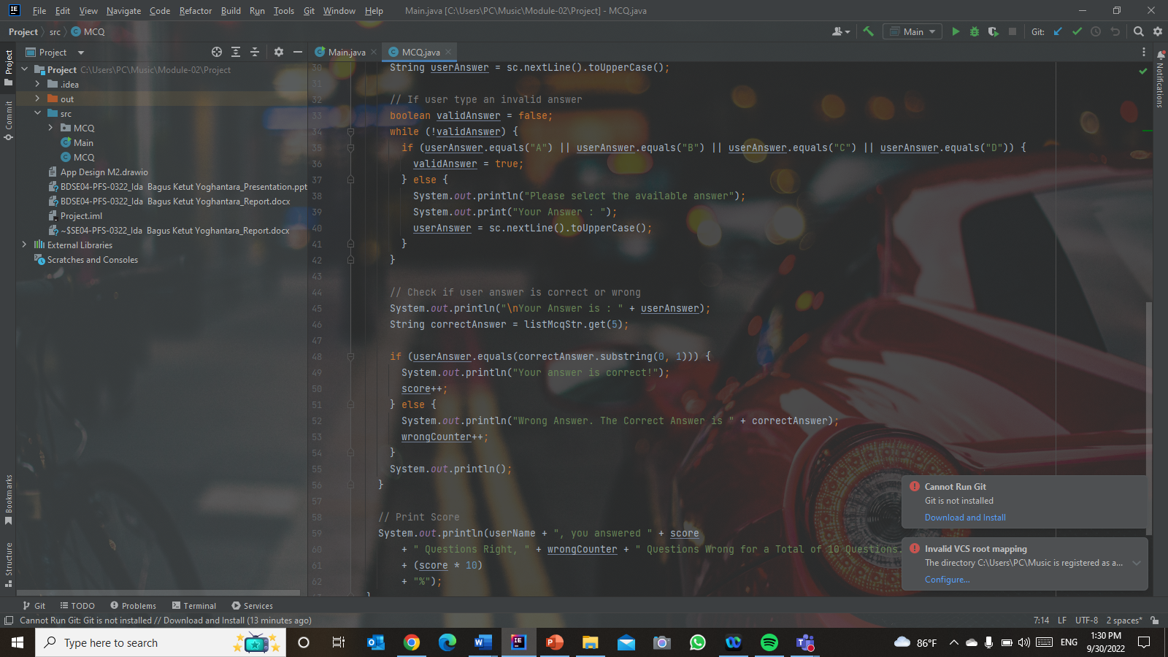

Figure 39:Screenshot of source code Implementation Step 7

**Output** – If answer is invalid,

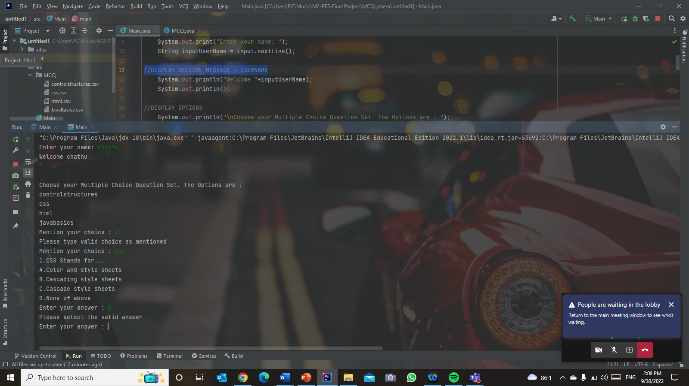

Figure 40:Screenshot of source code Implementation output Step 7(1)

**Output** – If answer is valid, it will continue

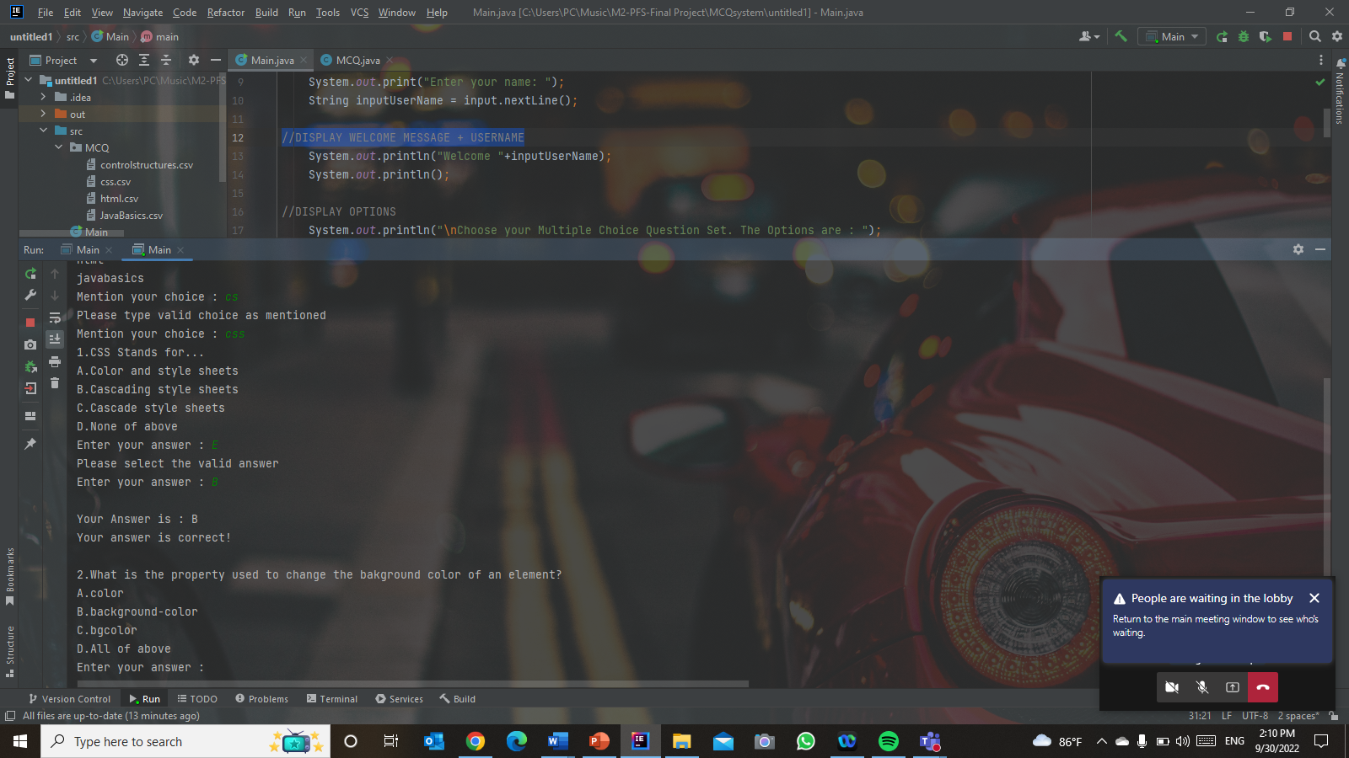

Figure 41:Screenshot of source code Implementation output Step 7(2)

**Step 8 -** Comparing the user answer and the correct answer, if user choose the correct answer, they will get 1 score

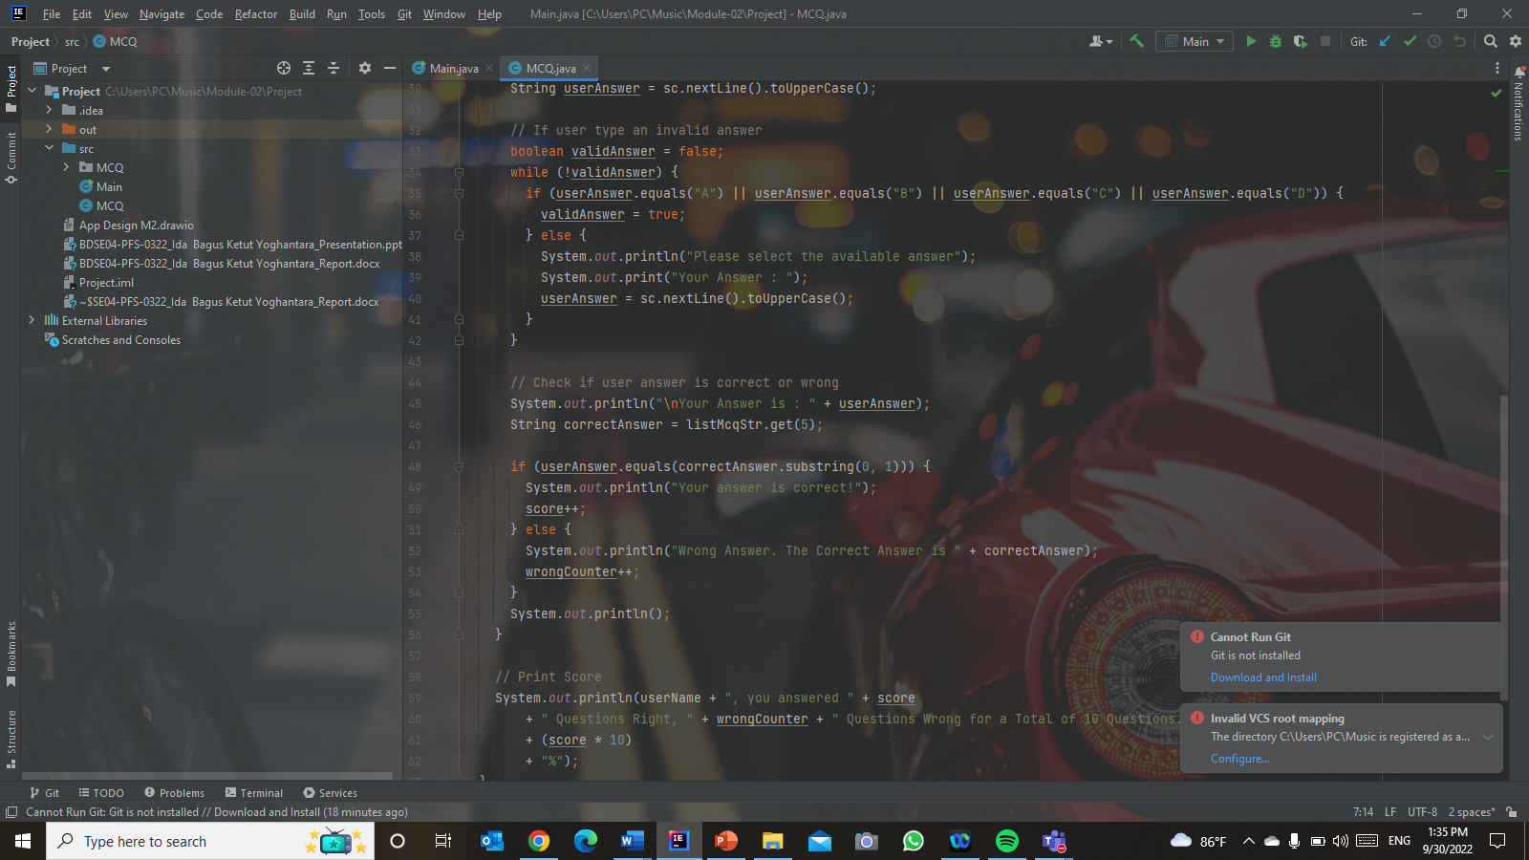

Figure 42:Screenshot of source code Implementation Step 7

**Step 10 -** Printing user score and let them know how many answers they get correct and wrong.

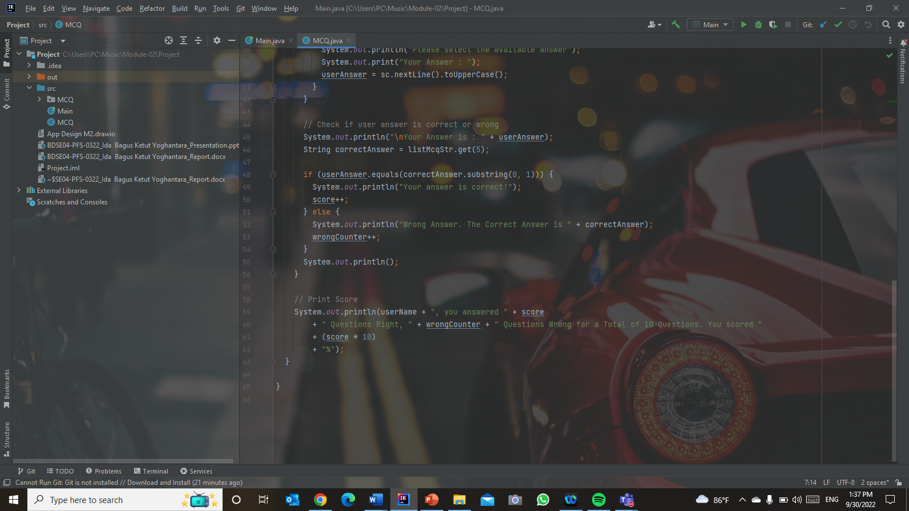

Figure 43:Screenshot of source code Implementation Step 8

**Output -**

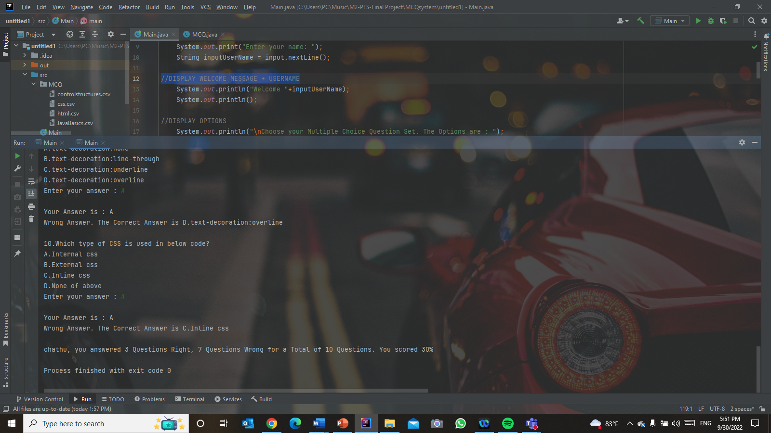

Figure 44:Screenshot of source code Implementation output Step 8

1. **The way that used object-oriented features to build the application**

The way that used object-oriented features to build this MCQ system is using the default constructor to create an MCQ object for the Main class.

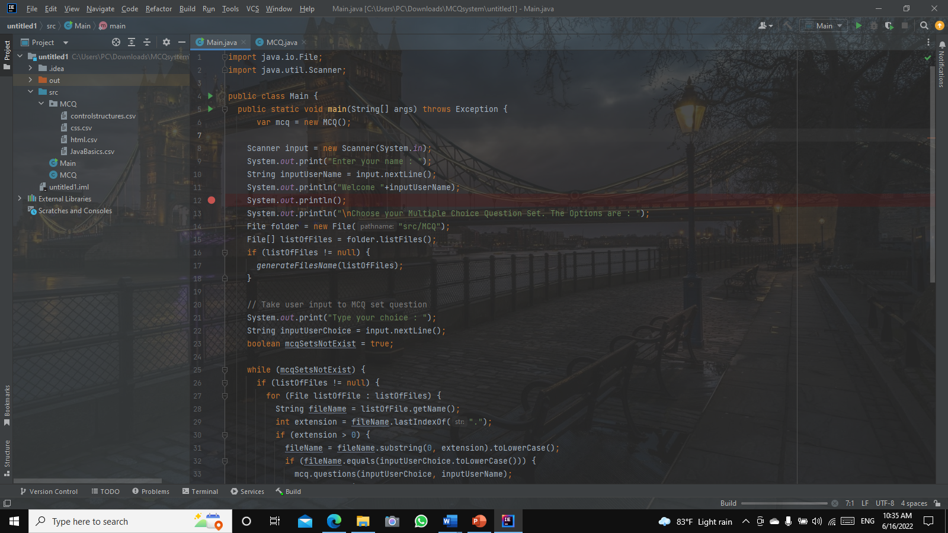

Figure 45:ScreenShot of the way that use OOP (1)

You can see that the question class is already inheriting all methods, even though after the if/else statement's justification, "System.out.println()" can add all strings to a line by using the "+" symbol, which is also an inheriting property. This is referred to be one type of overriding

Figure 46::Screenshot of the way that use OOP (2)

1. **Features that are available in IntelliJ**

* **Smart Code Completion**

IntelliJ is easy to handle because it provides keyboard shortcuts for many of its commands related to editing, navigating, redesigning, debugging, and much more that we might need to do on a regular basis**.**

* 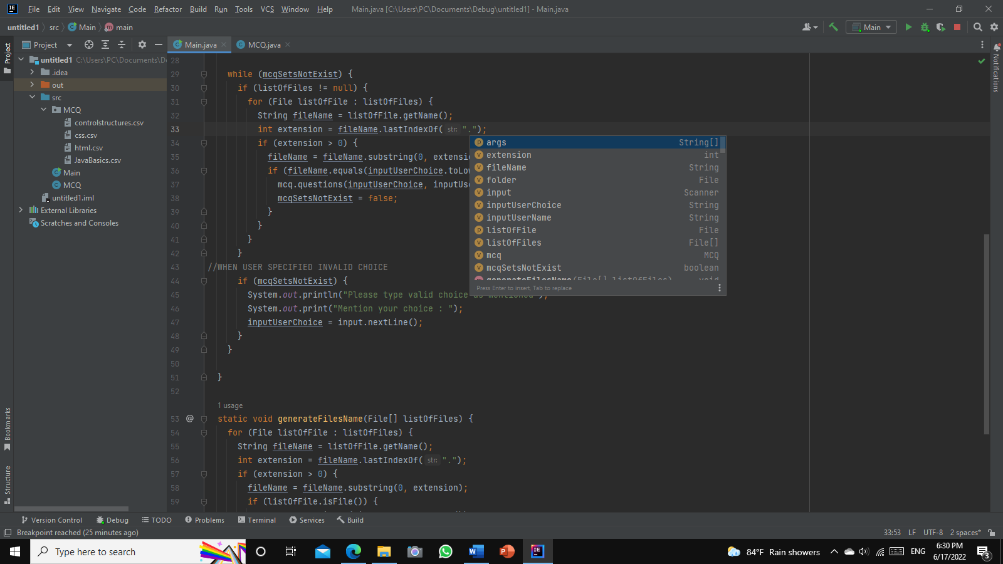CTRL + SPACE – Code completion/ Content assist

Figure 47:Screenshot of IntelliJ shortcuts (ctrl + space)

* **Infection and Quick Fix**

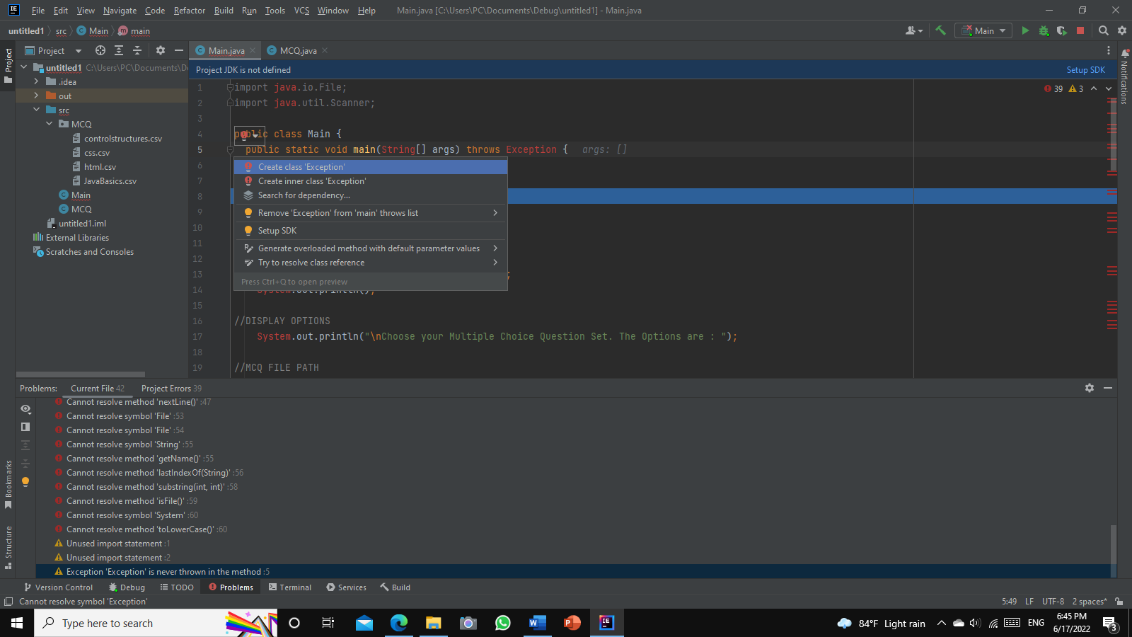If the user makes a mistake, IntelliJ quickly detects the error and pops up a small light bulb in the editor. When the user clicks on it (the bulb), it opens a list of actions that can be taken to correct things.

Figure 48:Screenshot of IntelliJ infection & quick fix

* **Automatic JDK Download**

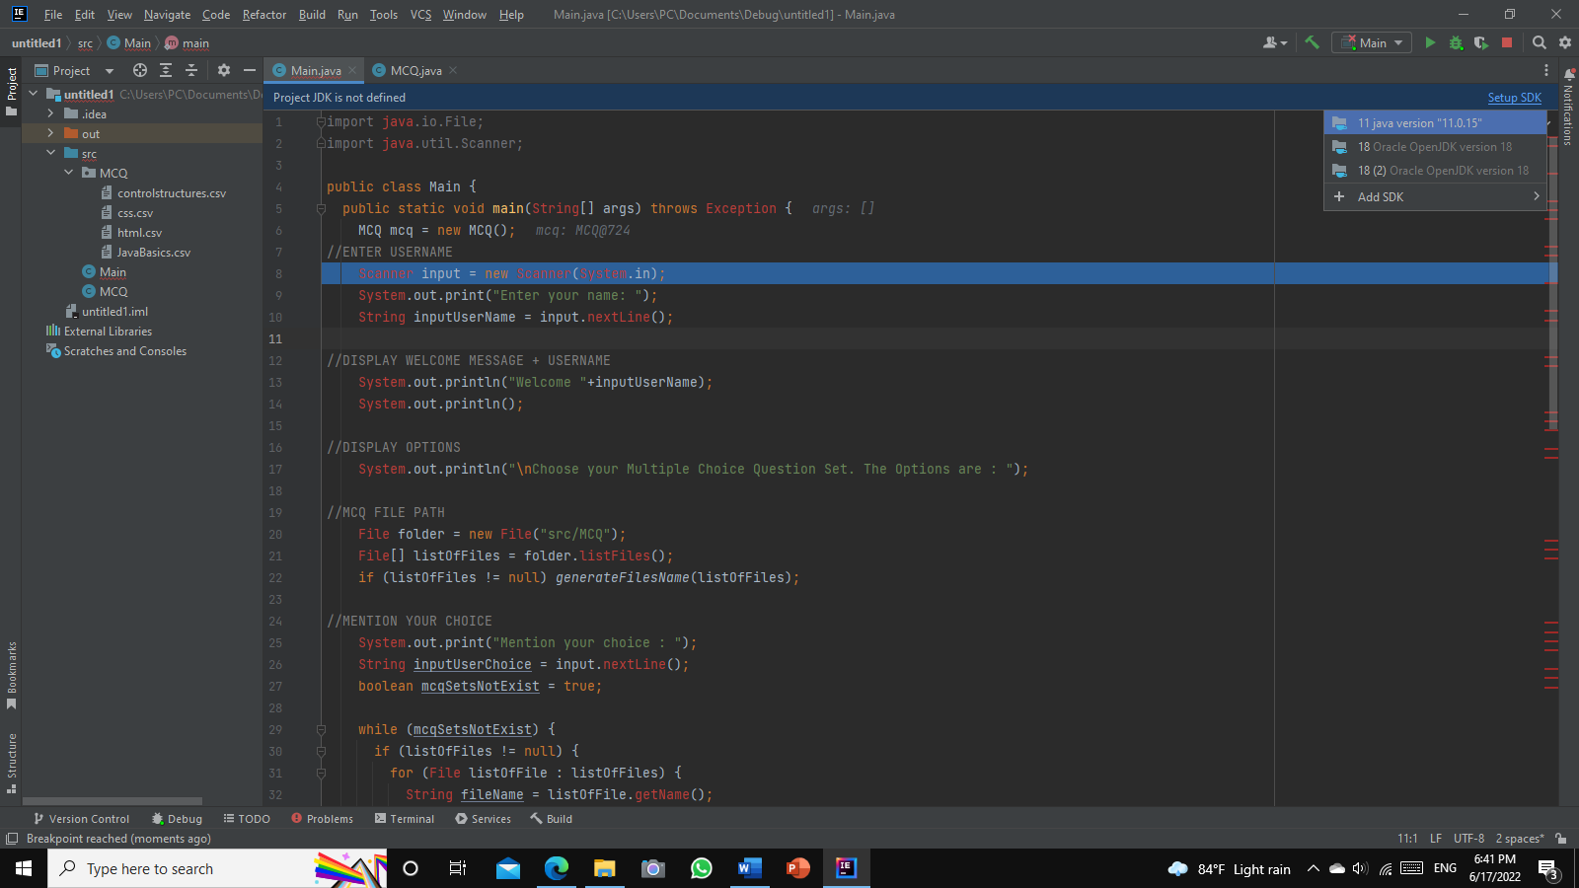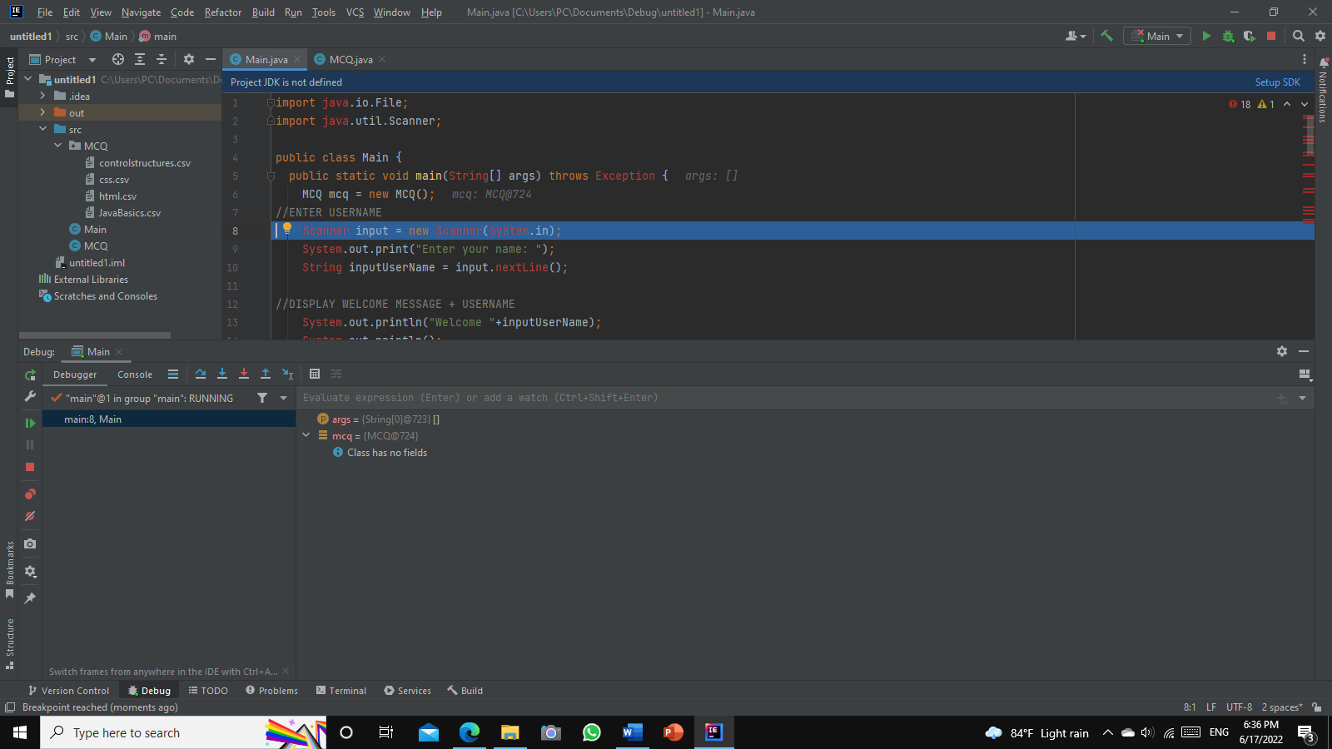This is a very useful feature because this feature integrated the downloading of JDKs directly into the IDE.

Figure 49:Screenshot of IntelliJ Automatic JDK Download

Figure 50:Screenshot of IntelliJ Automatic JDK download

* **Navigation and Search**

This is one of grate characteristic of IntelliJ which quickly navigate through code in the editor using different actions and popups.

* **Detecting Duplicates**

In java coding, this will help to find duplicate codes and provide suggestions to the user

# 13. How is it better to use IDE than not to use IDE?

By using an IDE,

During the method involved with composing, making, and testing programming, engineers utilize various instruments. Content managers, code libraries, bug following programming, compilers, and test stages are among the most well-known advancement devices. An engineer who doesn't utilize an IDE needs to pick, send, coordinate, and screen these instruments independently.

An incorporated improvement climate joins a few of these advancement related innovations into a solitary structure. At the point when all utilities are addressed on similar workbench, designers don't need to go through hours figuring out how to independently work them. This is likewise helpful for new designers who might utilize an IDE to find out about a group's standard devices and practices.

Most IDE abilities, like shrewd code finishing and programmed code creation, are intended to save time by taking out composition out total person arrangements. The incorporated toolset intends to make programming advancement simpler while additionally recognizing and lessening code mistakes and grammatical errors.

Other well known IDE highlights help engineers in smoothing out their work process and critical thinking. IDEs parse code as it is composed, distinguishing issues caused continuously. Most IDEs likewise incorporate linguistic structure featuring, which utilizes visual signs to perceive syntax in the word processor

By not using an IDE,

• you'll not have a compiler which could point out syntax errors.  
• You can't run the code, tweak it, and revise it till it really works.  
• You cannot run check instances against your code.  
• You can't step thru your code in a debugger.

1. **Steps related to debugging and how it can help develop more secure and robust applications**

The process of debugging requires 4 main stages. Namely, identify, isolate, fix & review. In the first stage of debugging user can identify and understand the issue of failure in the code. In the second stage, the user has to isolate the portion of the code in which debugging has to be performed. After understanding the cause of the failure, a fix can be provided to the faulty code, which can be finally reviewed and merged. Finally, it has to be fixed and reviewed.

When debugging in IntelliJ breakpoints will be inserted at appropriate places so that the requires variable values can be checked in detail or breakpoints are shown alongside the UI

Debugging Process,

* **Recognizing the Mistake.**

This is the piece of the debugging system that view as the most captivating. Since it's an exercise in futility to search for mistakes.

* **Locating the mistake.**

We should figure out how the mistake happened in the wake of acknowledging what turned out badly.

The objective of this stage is to distinguish the specific blunder.

* **Error investigation**

There, users might focus on unraveling the blunder.

* **Proof of examination**

In the wake of breaking down the blunder found, we really want to ensure that there could be no different mistakes subsequent to rectifying the past mistake.

* **Cover contiguous remuneration**

Subsequent to amending the newfound bugs we need to execute unit tests for this multitude of parts. We should breeze through the assessments in the event that what we have fitted is right.

* **Fixing and approving**

This step is to check assuming every one of the mistakes have been amended and to pursue the framework revising every one of the missed blunders and finishing every one of the assessments.

**15.1 The steps involved in debugging**

**Step 1** – Set breakpoints

To analyze how the program works at runtime, we want to suspend its execution before the associated piece with code. This is finished by setting breakpoints. Breakpoints demonstrate the lines of code where the program will be suspended for you to look at its state

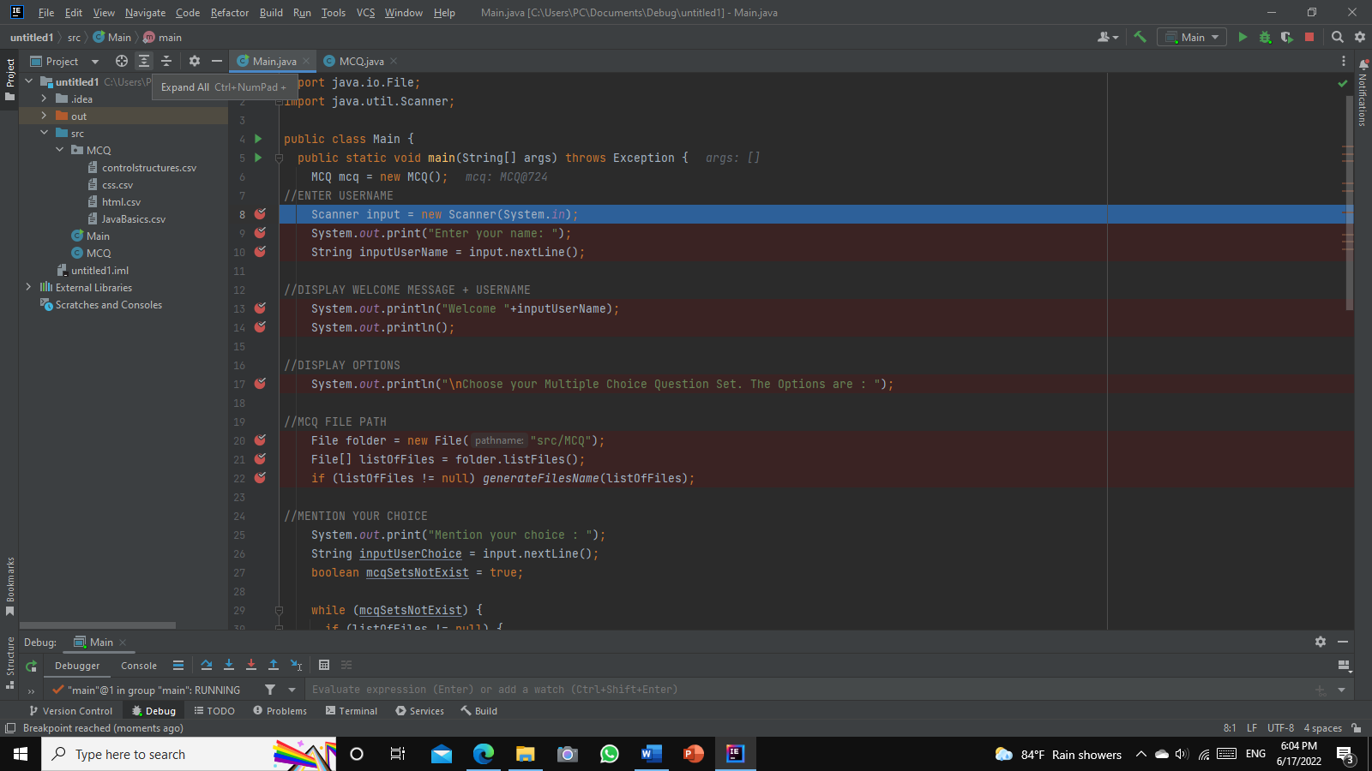

Figure 51:Screenshot of Breakpoints

**Step 2** – Debug the Main class

Figure 52:Screenshot of debug the main class

Now let's start the program in debug mode. Since we are going to pass arguments for running and debugging the program, make sure the run/debug configuration has these arguments in place.

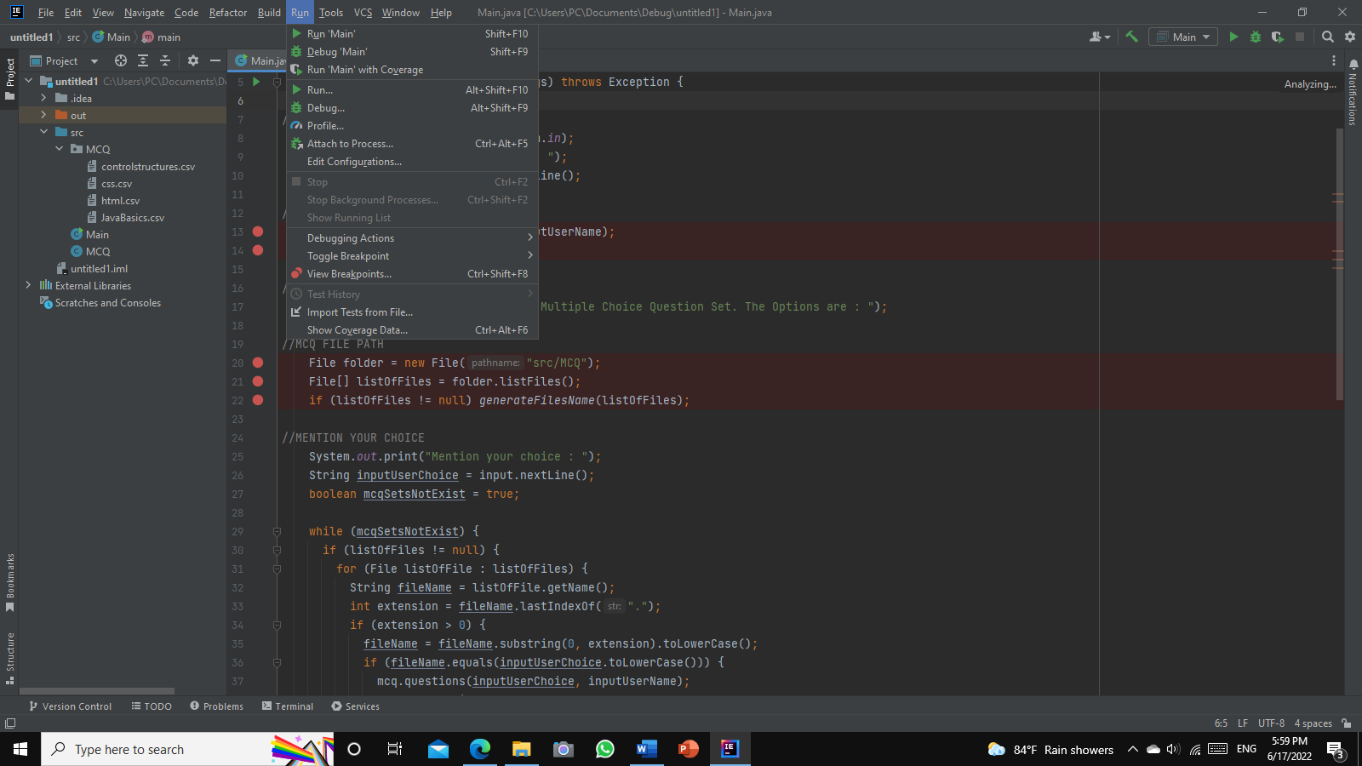

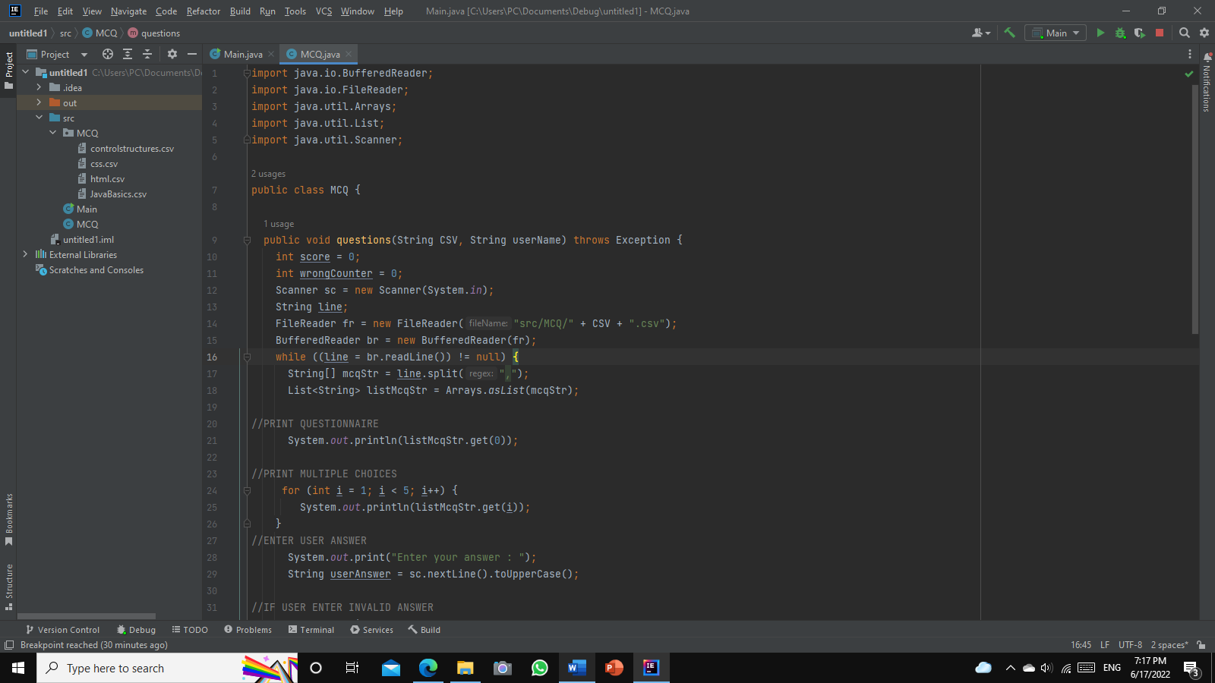To debug the program, click run then Debug “Main” or click the green color bug icon in the top right corner

Debug Icon

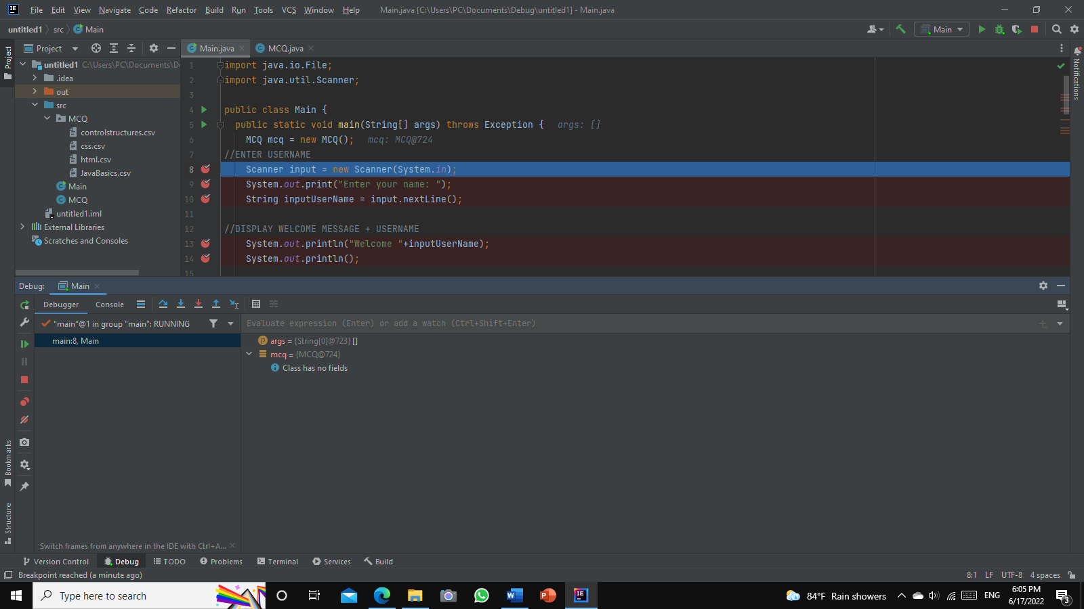**Step 3 –** Analyze the program state

Figure 53:Screenshot of IntelliJ program analyze

Once the debugging session starts, the MCQ system program will run normally until a breakpoint is reached. When this happens, the program’s paused, the line is highlighted and the debugging tool window appears.

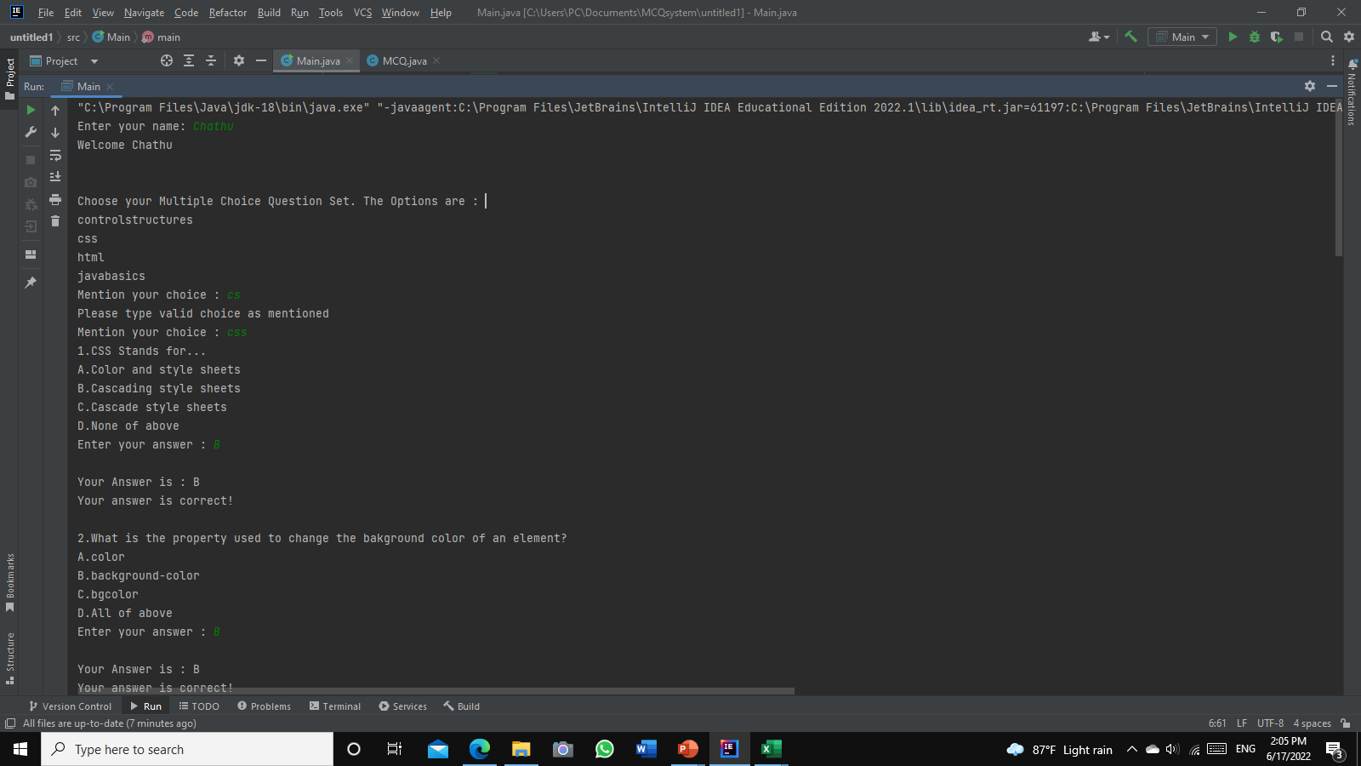**Step 4** – Step through the program and stop and return the debugger session

Figure 54:Screenshot of running program

1. **Coding standards**

## 15.1 Naming Convention

The Java Naming Convention is a set of rules that you must follow when deciding what to identify your identities, such as class, package, variable, constant, method

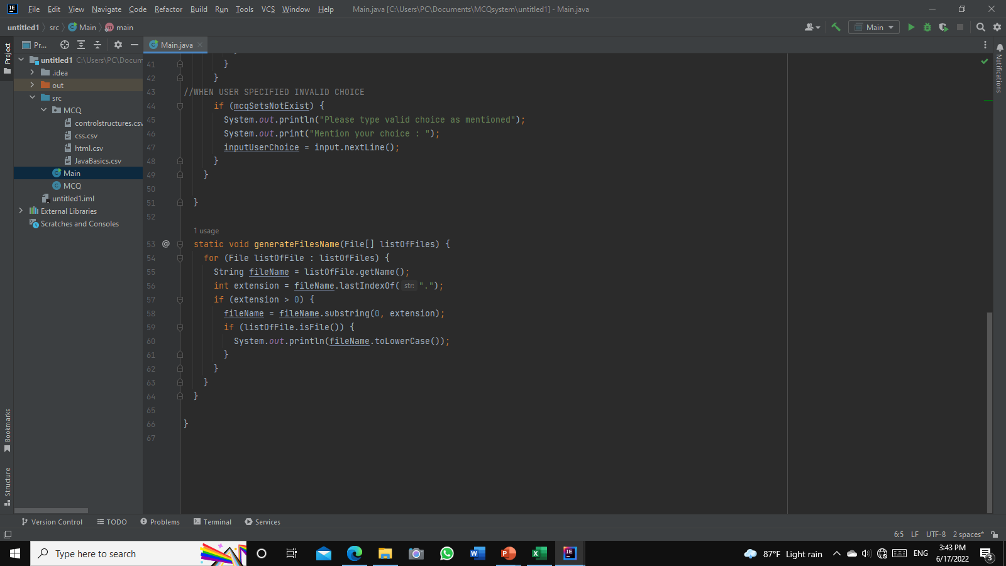

Figure 55:Screenshot of Coding Standards (Naming Convention) 1

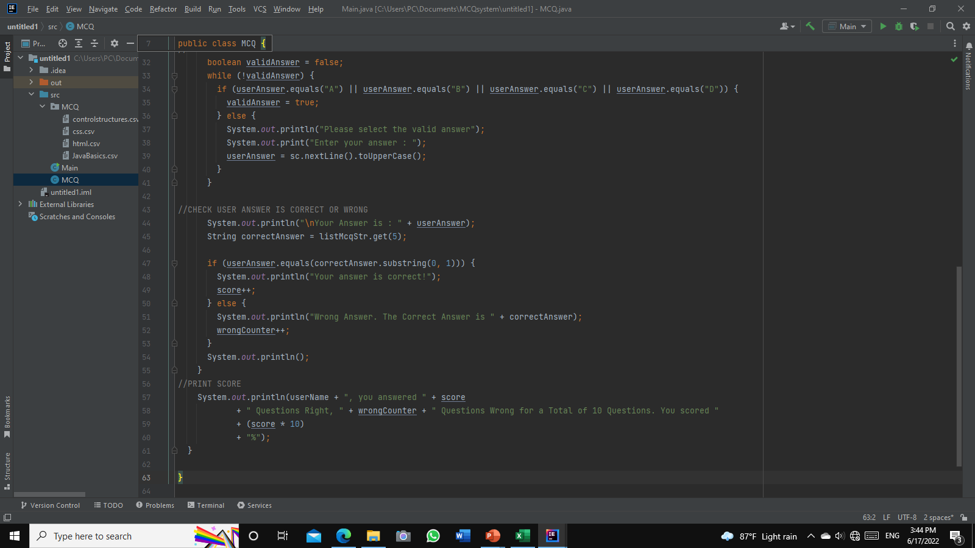

Figure 56:Screenshot of Coding Standards (Naming Convention) 2

## 15.2 Comments

Comment can be used to explain Java code and make it more readable & Can easily find the coding sections

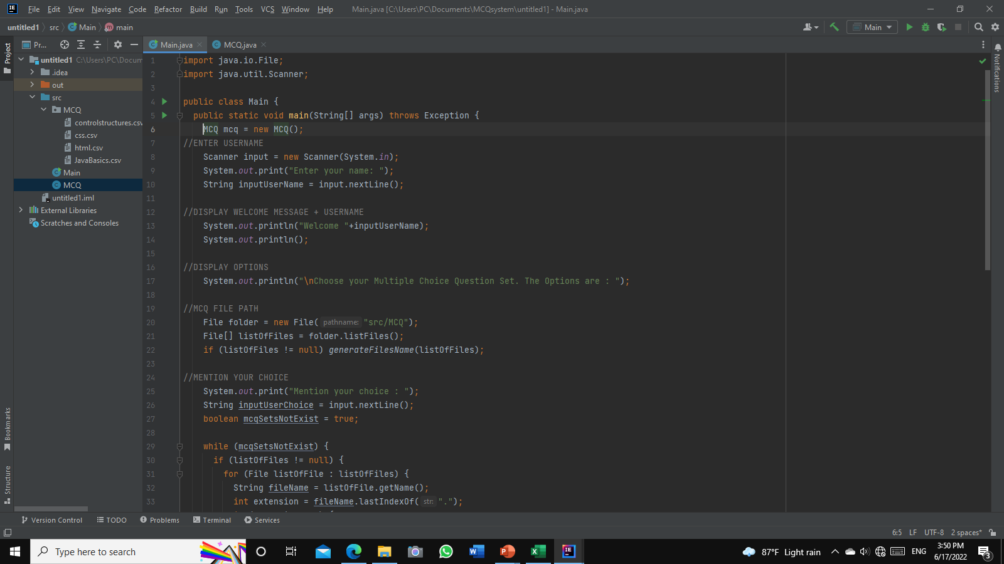

Figure 57:Screenshot of Coding Standards (Comments)

## 15.3 Maintain Indentation

It is like formatting. It’s easy to edit code, and shows the logic of the program in a well-organized way, making it easy for other users to read the code

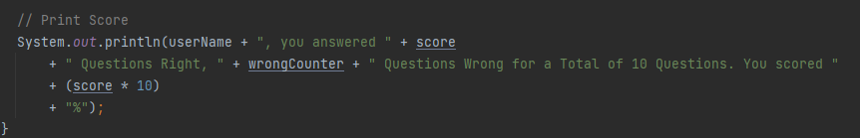

Figure 58:Screenshot of Coding Standards (Maintain Indentation)

## 15.4 Maintain white space

It is like formatting. It’s easy to edit code, shows the logic of the program in a well-organized way, making it easy for other users to read the code

**15.5 Using camel case for naming method or variable**

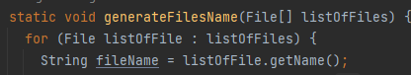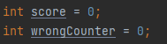

Figure 59:Screenshot of coding standards (Using camel case)